2012 年广东省初中毕业生学业考试
英 语

一、听力理解（每小题1分，共25分）
A、听句子（5分）
根据所听句子的内容和所提的问题，选择符合题意的图画回答问题。
1、What did Tom do last Saturday?
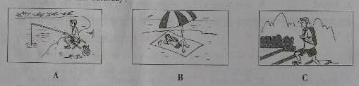
2.Why didn’t Peter want to have supper?
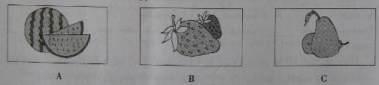
3.Where the students going to have classes?
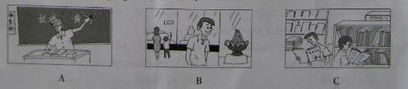
4.Who is Jimmv’s mother?
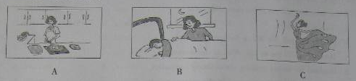
5.Which sige is the speaker talking about?
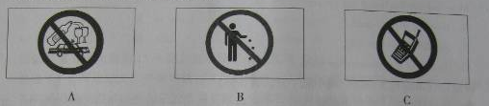
B．听对话（本题有10小题，每小题1分，共10分）
回答每段对话后面的问题，在各题所给的三个选项中选出一个最佳答案，并将答题卡上对应题目所选的选项涂黑。每段对话听两遍。
听第一段对话，回答第6小题。
6. What time will the woman pick up Peter?
A. 7:30. B.7:50. C.8:30.
听第二段对话，回答第7小题。
7. Why does the man like country music?
A. Because it's popular: B. Because it's exciting. C. Because it's relaxing.
听第三段对话，回答第8小题。
8. How will the weather be tomorrow?
A. It will be rainy. B.It will be fine. C.It will be snowy.
听第四段对话，回答第9小题。
9. Where does the conversation probably take place?
A. In the supermarket. B.At the bus stop. C.On the bus.
昕第五段对话，回答第10小题。
10. Who might these two speakers be?
A. Officer and soldier. B. Teacher and student. C. Boss and secretary.
听第六段对话，回答第11~12小题。
11. When will the man go to London?
A. On July 27"i. B.On July 28th. C.On July 29tr'.
12. How often does the man play tennis?
A. Once a week. B. Once a month. C.Twice a week.

听第七段对话，回答第13~15小题。
13. Whal does the girl need the computer for?
A. To write a letter. B. To search for information. C. To finish her report.
14. Why can't she ask Mr White for help?
A. Because he is not in his office at the moment.
B. Because he knows nothing about fixing computers.
C. Because he is giving a lesson in the classroom now.
15. How did the boy send his report?
A. He sent it by e-mail.
B He did it through QQ.
C He asked a classmate for help.
C. 听短文（本题有5小题，每小题1分，共5分）
请根据所听内容，在每小题给出的三个选项中，选出一个能完成句子的晟佳答案，并将
答题卡上对应题目所选的选项涂黑。短文听两遍。
16. Jiang Mei just returned from _________.
A. England B. Australia C. Canada
17. Jiang Mei found people there say "_________." when others ask them "How are you?"
A. I am busy B. I am good C. I don't know
18. Jiang Mei was surprised to find the students there _________.
A. lazy B. sad C. hard-working
19. From the story, we know Jiang Mei once learned to _________.
A. write music B. play the violin C. play the piano
20. The story mainly told us about Jiang Mei's _________ in another country.
A. travel B. study C. friends
D. 听填信息（本题有5小题，每小题1分，共5分）
你将听到的是一篇关于volunteer acLivity （志愿者活动）的短文，请你根据所听内容填写下面的信息卡。并请将答案写在答题卡相应题目的答题位置上。短文听两遍。
Information About the Volunteer Activity  Place: Starlight Old People's Home  Time: This (21) _________  The number of students on each team: (22) _________  Tasks for each team:  *Team l: Clean the floor and (23) _________ the rubbish.  *Team 2: Put up some beautiful (24) _________ on the walls  and put some flowers in the rooms.  *Team 3: Sing and dance to make the old people (25) _________.  *Team 4: Wash the clothes for the old people. | 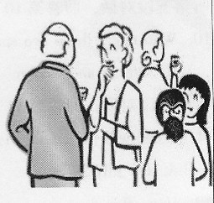

二、单项填空（本大题有20掌上小题，每小题1分，共20分）
在每小题的四个选项中，选出可以填入空白处的最佳答案，并将答题卡上对应题目所选的选项涂黑。
( )26. _____Greens are preparing for the coming Thanksgiving Day.
A. / B.A C. An D. The
( )27. –Which basketball player do you like best, Kobe, James or Jordan?
-- _______ of them .Lin shuhao is my favorite.
A. All B. None C. Either D. Neither
( )28. The students of Grade 7 visited Mike’s farm and saw many _____there.
A. bird B.duck C. sheep D. rabbit
( )29. --- how was your weekend?
---- Great! It was my grandfather’s _______ birthday. We enjoyed ourselves.
A. seventy B. seventieth C. the seventieth D. seventeenth
( )30. --- did you go to the cinema to see 3D Titannic last night?
---- No, I ________ go to the cinema . The tickets are too expensive
A.hardly B. nearly C. still D.only
( )31. Jenny _____in the chicken when you called her at 5 o’clock this afternoon?
A. is cooking B. was cooking C.cooks D. cooked
( )32. — Why are you standing, Alice?
—I can’t see the blackboard clearly. Two tall boys are sitting_______me.
A.behind . B.next to C.between D.in front of
( )33. Ben was busy taking a training class. ______we had to wait for himfor half an hour..
A.sol B. if C. or D. but
( )34. —________ I swim here?
—I’m sorry. Children _______ swim alone here.
A. Must , can’t B. May , must C.Can, mustn’t D. Can’t can
( )35. Hot water_____ in the students’ flats from 5 pm to 7 pm now.
A. supplies B. is supplied C.supplied D. was supplied
( )36. — If our government _____attention to controling food safety now, our health _____in danger.
A.won’t pay, is B. doesn’t pay, is C. won’t pay, will be D. doesn’t pay, will be
( )37.--- Both Li Lei and Han Meimei _______ fond of the TV program A Bite of China.
---- I am also deeply moved by its stories.
A. is B. am C. was D.are
( )38. --- My new iphone was stolen when I took a bus yesterday.
---- ____________.
A. I’m sorry to hear that B. it doesn’t matter.
C.Don’t be silly D. I’d love to
( )39. Our English teacher is very nice. We _____ friends since three years ago.
A.were B. became C. have been D. have made
( )40. Eighteen kids died in the school bus accident in Gansu Province. It’s _____ one that I have ever heard of.
A. a very serious B. a more serious C. the most serious D. the least serious
( )41. I love this song by Lady Gaga. Would you _____ the TV a bit, please? I can’t hear it clearly.
A. turn on B. turn off C. turn up D.turn down
( )42. There will be a flower show in the park________ we visited last week.
A. who B. when C. what D. which
( )43. —You haven’t been to the West Lake, have you?
—_____. But I will go there with my parents this summer vacation.
A.No, I haven’t B.No, I didn’t C.Yes, I have D. yes, I did
( )44. It took me two weeks ____ reading the novels written by Guo Jingming. .
A. finish B. to finish C. finishes D. finishing
( )45. --- Could you tell me_____ ?
---- Certanily. In half an hour.
A. when will the high speed train arrive B. when the high speed train will arrive
C. when would the high speed train arrive D. when the high speed train would arrive
三、完形填空。(本大题共10小题，每小题1分，共10分)
通读下面短文,掌握其大意,然后在各小题所给的四个选项中,选出一个最佳答案,并将答题卡上对应题目所选的选项涂黑。
Bill, a thirteen-year-old boy, thought he had grown up to be a man. But his parents told him, “ You won’t be a real man until you begin to_46_____ helping others.”
One morning, his parents gave him some money to 47____ some milk for them. Outside a shop he saw a homeless old man who looked very 48____. Bill went to him and asked, “ What’s wrong with you?”
The old man answered, “ I’m hungry. I haven’t had any food for two days.”
All the thought of his parents’ words, Bill said to the old man, “Let’s go to the 49_______.”
When they got there, Bill asked the waiterto bring out bread and coffee to the old man. The old man finished the meal quickly. After the waiter 50_____the plate and the cup, the old man said, “Sorry for give you too much 51_____. I’m fine now. I’ll 52____ forget your kindness! You are a very good young man”
Bill was 53______ when he heard this. Just when he wanted to pay for the meal, the waiter came. Bill and the old man learned 54______ that he food was free 55___ it was the birthday of the boss, and they were the first customer(顾客) that day.
46. | A. think about | B.depend on | C.give up | D.go on
47. | A.lend | B.buy | C.drink | D. borrow
48. | A.afraid | B.glad | C.sick | D.angry
49. | A.bank | B.library | C.hospital | D.restaurant
50. | A.sent out | B.got down | C.gave back | D. took away
51. | A.excuse | B.advice | C.trouble | D.difficulty
52. | A.never | B.always | C.usually | D.sometimes
53. | A.nervous | B. pleased | C.sorry | D.shy
54. | A. in surprise | B.as usual | C.once again | D.at first
55. | A.when | B.until | C.unless | D. became
四.阅读理解(本大题有15小题,每小题2分,共30分)
阅读A、B 两篇短文，并做每篇短文后的题目。从每小题所给的四个选项中，选出能回答所提问题或完成所给句子的最佳答案，将答题卡上对应题目所选的选项涂黑。
A
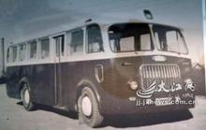
OUR BUSES CAN
MAKE YOUR HOLIDAYS

East Bus -– maybe the best choice on your visit to the famous places of interest in Beijing.
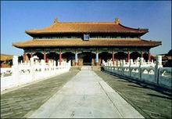
Sit back, relax and see all there is to see, with no need to worry about driving, finding a parking place or leaving your car with no one to watch it.
We have lots of buses taking you to visit Tan’anmen Square, the Fofbidden City, the Summer Palace, the Templeof Heaven Park, the Olympic Center and the Great Wall. The whole tour will take you there three days.
Chinese & English speaking guides.
Booking by photo four days advance(预先).
Tour price: ￥580.00 per person( half price for children under 1.2m tall), including the ticket price,breakfast and lunch.
For more information, please phone Yong’an Tourism Company at 010-23368688/23368689.
Add: 356 Chaoyang Road, Beijing.
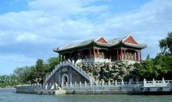
Open 7 days a week.8:00-16:00
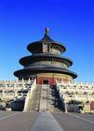
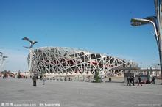
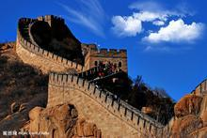

56.When they visit the places of interes on an East Bus, the visitor______.
A.need to watch their cars |  | B.have to worry about the driving
C.have to find places to pasrk their car |  | D.can sit back and relax themslves
57.From the advertisement, we can see that East Bus is a kind of_________.
A.tourist bus | B.village bus |  | C.airport bus | D.school bus
58.________ on ab East Bus can speak two languages.
A.The guide | B.The driver |  | C.The visitors | D.The children
59.Children under 1.2m tall need to pay ____ for the trip.
A.230 yuan | B.290 yuan |  | C.320 yuan | D.460 yuan
60.which of the following is NOT true?
A.The tour price includes six meals
B.Visitors can see six places within three days.
C. Visitors mst go to the company to book the tickets.
D.The office hour of the company is eight hours a day.
B
Fifty-three years ago Barbie Millicent Roberts first appeared in the world of toys.
Since then, Barbie doll, as everyone called her,has become the most successful toy doll in history. Her parent,the Mattel Company,said that 90% of all Ame”rican girls between 3 and 10 have at least one Barbie at home.
However, Barbie is facing some trouble at present (现在). There are many similar dolls on the market in competiotion with her. Another doll named Bratz, for example, come to life thirteen years ago. She looked more like today’s pop stars with heavy makeup(浓妆) and miniskirts. And her company offers more kind of clothes too.
It seems that Barbie has lost her magic among older girls. “ For younger girls, playing with a Barbie is much fun. But when you get older, you want something smarter and more modern,” says Vera Shepherd, a shop assitant in a New York toy store.
It is good news that on the international market. Barbie is still No. 1. although Mttel is selling ferwer Barbies int the United States three years, sales in other countries are still going up.in January 2009, Mattel openee its first Barbie store in Shanghai, where girls can shop, eat, drink or even become fashion designers for their own Barbies.
Mattel is planning big celebration for Barbie’s 53rd birthday. Fashion designers from all over the world have been called to make new dresses for Barbie. How long will Barbie stay popuplar in the world of toy dolls? It is hard to say, but 53 is surely not the age to retire(退休)。
61. Barbie’s family name is______.
A.Roberts | B.millicent | C.Shepherd | D.Bratz
62.Barbie’s trouble is that__________.
A.it wears heavy makeup and miniskirts.
B.other dolls are more popular with little girls.
C.other dolls are trying to beat her in the market.
D.it has become less popular in the international market.
63.Girls can do the following in the first Barbie shop in Shanghai except_______.
A.going shopping | B.having food | C.drinking juice | D.taking photos
64. What’s the meaning of the underline words “fashion designers” in the passage?
A.珠宝设计师 | B.发型设计师 | C.舞台设计师 | D.服装设计师
65. What is the best title of the passage?
A.First Barbie Shop in Shanghai |  | B.Barbie’s Past and present
C.Barbie’s 53rd Birthday Party |  | D.Barbie Lost Her Magic

C.
配对阅读 左栏是五位病人的健康问题，右栏是七位专科医生的简介。请根据五位病人的健康问题为他们选出最合适的专科医生诊病，并将答题卡上对应题目所选的选项涂黑。
66. Kent has endless work to do every day. He has trouble getting to sleep at night and usually stay awake till 2 am.  67. 8- year-old Dongdong has a sweet tooth. He has already had four bad teeth and his mom is worried about his toothache.  68.Llin’s father has been a heavy drinker for 20 years. He decided to give up drinking after the body check which showed some thealth problems.  69. Recently Betty eats what ever she likes, including lots of meat. She has found herself putting on weight week by week but just can’t stop eating.  70. Nina has a high fever because of the flu she caught at school. She has such a big headache that she can’t go to school. | A. Dr. Yang has developed a new treatment to help patients give up drinking. She aslo does well in curing (治愈) diseases caused by drinking.  B. If you break or lose your teeth, go to dr. Smith’s.. He has different kinds of false teeth for people aged over 20, and helps you feel good about yourself.  C. Dr. Li got a doctor’s degree in traditional Chinese and western medicine. He is good at treating flu (fever, cough etc.) in both traditional Chinese and western medicine ways.  D. Dr. Chen has a lot of experience in helping patients get normal sleep. She not only gives them medicine care but also provides advice on how to relax from busy work.  E. Dr. Wright is always ready to offer help on eating problems. He believes each patient needs a different plan to control his /her wish to eat.  F. Dr. Liu, one of the best dentists in Guangdong General Hospital, has great skills in fixing had teeth and communicating with kids to win their trust.  G. Dr. Grey is one of the top doctors in the field of heart diseases. She used to work in America for three years and is good at doing heart operations.

五、 短文填空（本大题有10小题，每小题1.5分，共15分）
请用适当的词完成这篇日记，每个空只能填写一个形式正确、意义相符的单词。

Nov. 26, 2011, Saturday
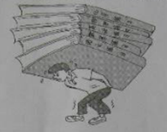
I’m upset these days. I have_71____ problem, and I do not 72_____ how to deal with it.
I have had a lot of _73______ every day since I became a Grade 9 student. I have no choice but to do it.. I oftern stay up lateto finish it and then feel 74 ____ the next day.
75______ I undrestand that it is important to do my homework and _76____ it in on time. Sometimes I still don’t want to do so much homework. I almost have no free timefor my hobbies, 77_____ as playing volleyball and ping-pong. The worst thing is that I even have homework on weekends and holidays. The longer the holidays are, the 78_______ homework I get. I really feel bad about it.
I am looking forward to a holiday79_______ homework so that I can relax and have some time for my hobbies. What should I do? I really hope that someone can give 80____ some suggestions. I am sure they will be of great value to me.
71.__________ 72.__________ 73.__________ 74.__________ 75.__________
76.__________ 77.__________ 78.__________ 79.__________ 80.__________
六.读写综合(本大题分为A,B 两部分,共20分)
A) 信息归纳(本题有5小题,每小题1分,共5分)
请阅读下面这篇文章，根据所提供的信息，完成下面表格，把答案写在答题卡指定的位置上。

BBC World Have Your Say: “ Life in China”
Every day, BBC News on TV,radio and online brings you stories from across the world. But what we want to hear are the stories that matter to you.
Have got a story about life in China today? If you do, please put your stories here.
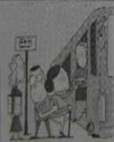
I like travaling and I have traveled a lot around China. During the trip, I often find that a number of Chinese don’t have good pulic manners(举止). They always loudly on the phone and smoke everywhere. The worst is that they often break the rules in public. For example, when I travled in HongKong in January this year, I saw a kid eating noodles on the underground , which is against the rules. However, the kid’s mother didn’t think he did wrong. Can you believe it? Let’s improve our public manners. (Mike, Shenzhen)
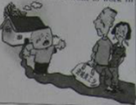
I am a 14-year-old boy from a poor village in Fuyang , Anhui Province. Like many other left-behind children(留守儿童)in China, l live with my grandparents now. my father went to work inn Shanghai several years ago. Last year, my mother went there to care for him because his health is not as good as before. They tell me to listen to my grandparents and call me about twice a month to ask about my study. I really miss my parents ans I hope I can afford to go to school in Shanghai. I think every child needs parents’ love and care. (Wu Peigen, Anhui Province)

Information card
The topic of BBC. World Have Your Say today | 81.
The thing that the kid did on the underground | 82.
The time when Mike traveled in HongKong | 83.
Wu Peigen’s age | 84.
People who live with Wu Peigen now | 85.

B） 书面表达（本题15分）根据要求完成短文写作，请将作文写在答题卡指定的位置上。
假如你是一名叫李明（Li Ming）的中学生，看了上述故事后，你想表达自己的看法。 请你给栏目编辑写一封电子邮件，内容包括：
- 你对其中的哪个故事感兴趣？原因是什么？
- 你对这个故事所提及的现象的看法。
- 就该现象提出至少两条解决问题的建议。
作文要求：
- 不能照抄原文；不得在作文中出现学校真实的名称和学生的真实姓名。
- 语句连贯，词数80个左右。作文开头和结尾已经给出，不计入总词数，也不必抄写在答题卡上。
Dear Editor,
I read the stories on BBC World Have Your Say today,__________________________________________
____________________________________________________________________________________________________________________________________________________________________________________________________________________________________________________________________________________________________________________________________________________________________________________________________________________________________________________________________________
Your,
Li Ming

