乐山市2012年高中阶段教育学校招生统一考试
英 语
第一卷（选择题，共105分）
第一部分：听力（共三节，满分30分）
第一节（共5小题；每小题1.5分，满分7.5分）
听下面5段对话。每段对话后有一个小题，从题中所给的A、B、C三幅图中，选出一个与你所听到的内容相符合的选项，并标在试卷的相应位置。每段对话读两遍。
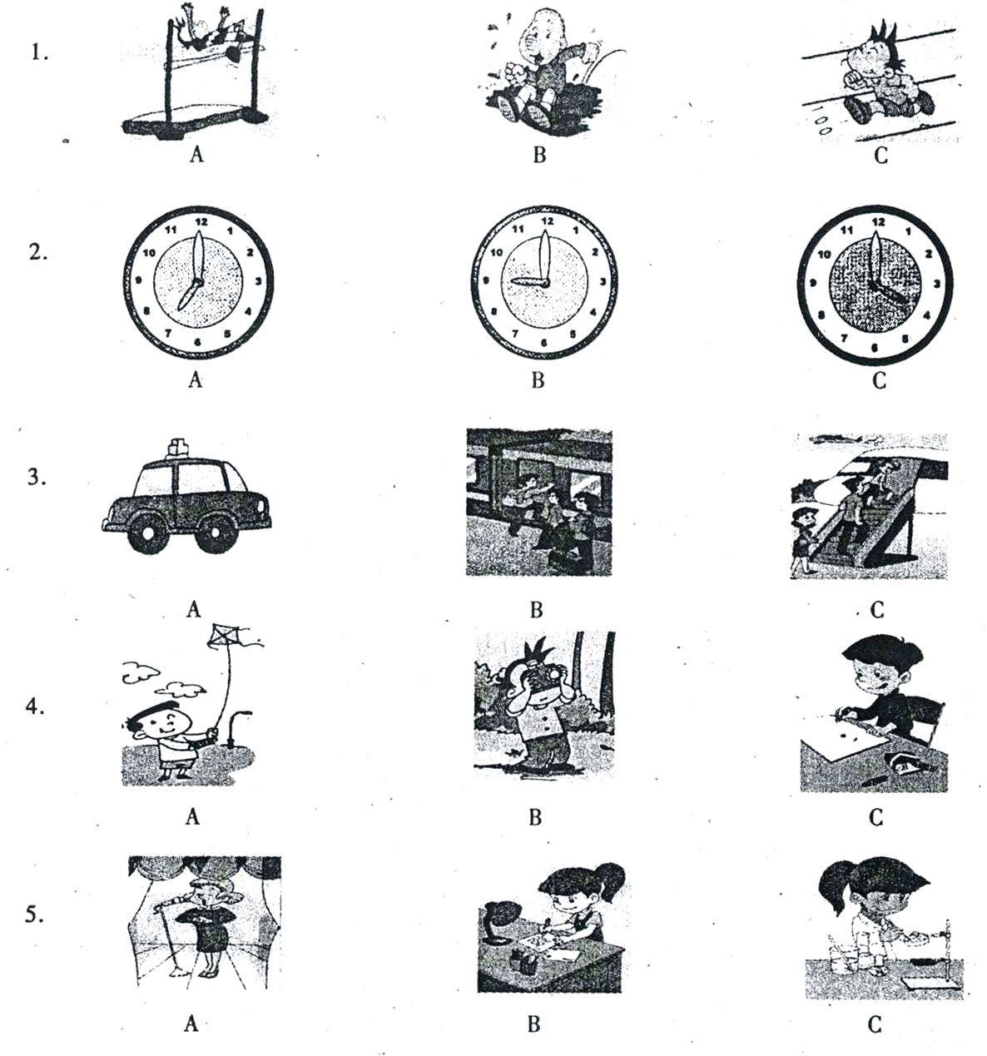

第二节（共5小题；每小题1.5分，满分7.5分）
听下面5段对话。每段对话后有一个小题，从题中所给的A、B、C三个选项中选出最佳选项，并标在试卷的相应位置。每段对话读两遍。
6. What does the man want to borrow from the woman?
A. A line. B. A camera. C. A telephone.
7. What are the speakers probably going to do?
A. Go to a music show. B. Go to a movie. C. Go to a match
8. Why is the woman unhappy?
A. She misunderstood her mum.
B. She fought with her best friend.
C. Her mum doesn’t like her friend.
9. According to the woman, when is the best time to visit Italy?
A. In May. B. In July. C. In August.
10. What’s the woman’s advice?
A. Eat more sweets. B. Do some exercise. C. Let him be.
第三节（共10小题；每小题1.5分，共15分）
听下面3段对话或独白。每段对话或独白有几个小题，从题中所给的A、B、C三个选项中选出最佳选项，并标在试卷的相应位置。每段对话或独白读两遍。
听下面一段材料，回答第11至13题。
11. What does the woman say about Paul in class?
A. He talks a lot. B. He is sleepy. C. He plays games.
12. Where will the man put the computer?
A. In the living room. B. In his bedroom. C. In Paul’s bedroom.
13. What’s the possible relationship（关系）between the two speakers?
A. Teacher and student. B. Teacher and father. C. Mother and son.
听下面一段材料，回答第14至16题。
14. How many rocks has the man collected?
A. About 6. B. About 16. C. About 60.
15. Why is the man most interested in collecting rocks?
A. He thinks collecting rocks takes little time.
B. He likes rock’ interesting shapes and colors.
C. He believes it is a good way of making friends.
16. Where are the man’s rocks kept?
A. In the living room. B. In his study. C. In his bedroom.
听下面一段材料，回答第17至20题。
17. Why do people celebrate Mother’s Day?
A. It is a day to thank mothers.
B. It is time to plan family outing.
C. It is time for mothers to take a day off.
18. Who had the of having Mother’s Day?
A. Ann’s mother.
B. Some important persons.
C. An American woman called Ann.
19. When is Mother’s Day?
A. The first Sunday in May.
B. The second Sunday in May.
C. The second Saturday mainly talk about?
20. What does the passage mainly talk about?
A. The history of Mother’s Day.
B. How to plan family party.
C. How to make birthday cards.
第二部分：英语知识运用（共2节，满分30分）
第一节：语法和词汇知识（共15小题；每小题1分，满分15分）
从A、B、C三个选项中，选出可以填入空白处的最佳选项，并在答题卡上将该项涂黑。
21. —I’m very tired. I can’t go any further, Jenny.
— ,Tommy. You can do it!
A. Come on B. You are right C. That’s OK
22. he has little knowledge, the old worker has a lot of experience.
A. Although. B. Because. C. If
23. One of the advantage of playing guitar is that it can give you a great deal of pleasure.
A. a B. the C. 不填
24. We forgot to bring our tickets , but please let us enter, ？
A. do you B. shall we C. will you
25. —Have you known Dr. Jackson for a long time?
—Yes, since she the Chinese Society.
A. joined B. joins C. has joined
26. When asked what they needed most, the kids said they wanted to important and loved.
A. turn B. sound C. feel
27. Sarah had her washing machine yesterday, but it doesn’t work now.
A. repair B. repaired C. to repair
28. Tony is very nice. He is the most enjoyable person I .
A. meet ever B. have ever met C. had ever met
29. A typhoon hit this area with heavy rains and winds strong as what happened in 2008.
A. as B. so C. too
30. In order to finish the project, we’ll have to work hours a day.
A. more two B. two more C. two another
31. If you can’t decide which of the two books to borrow, why don’t you take ? I won’t read them this week.
A. all B. either C. both
32. —Do you have any problems if you five minutes to read?
—Well, I’m thinking about the new words. There are too many.
A. give B. are given C. will be given
33. The digital camera it very popular, but some still too much.
A. cost B. spend C. pay
34. —Have you got any idea for the summer vacation?
—I don’t mind . It will be OK if there is sun, sea and beach.
A. where do we go B. where we go C. when we go
35. —It’s a top secret.
—Yes, I see. I will keep the secret you and me.
A. with B. among C. between
第二节 完形填空（共15小题，每小题1分，满分15分）
阅读下列短文，掌握其大意，然后从36～50各题所给的三个或四个选项中，选出最佳选项，并在答题卡上将该项涂黑。
A
In the US, when your school doesn’t have a bus, and you live too far to walk, you need a carpool（拼车）.A carpool is a group of 36 sharing a car to school in the morning. There are 37 four or five kids in their cars. Parents take turns driving the kids in their cars.
Teamwork （协作）is really important in the carpool because nobody wants to make 38 late for class. If you sit in the car and wait for a classmate for a long time, you’ll probably get a little 39 . Also, your carpool friends might feel the 40 way when you keep them waiting.
You learn a great 41 in responsibility（责任）in the carpool before school ever starts.
36. A. teachers | B. drivers | C. students
37.A. usually | B. hardly | C. already
38.A. another | B. the other | C. the others
39.A. angry | B. worried | C. tired
40.A. different | B. wrong | C. same
41.A. use | B. lesson | C. work

B
My parents took me to England when I was a boy. I lived there for 3 years. When I came back, I could speak English quite well. “I must do something 42 with my English.” I said to myself. Not long after that, I got a good 43 . Because of serious illness, I stayed home with nothing to do. My father brought me an English book. “Why don’t you 44 into Chinese? It could make you English much better.” I 45 to translate 1，500 words each day. But later I found it very 46 to keep the promise. One day, I wanted to go out because the weather was sunny. But those 1，500 words hadn’t been translated yet. 47 wished I could just go outside and play football with my friends! I just wanted to 48 . I really couldn’t control(控制) myself. I rushed out of the door. 49 the way to the playground, I didn’t feel so happy that I could not enjoy myself. Suddenly I remembered the words my parents had told me, “Whatever you do, don’t stop halfway.” So I turned back and 50 with the translation.
42. | A. useful | B. funny | C. hopeful | D. serious
43. | A. excuse | B. idea | C. chance | D. rest
44. | A. add | B. make | C. send | D. translate
45. | A. failed | B. promised | C. refused | D. advised
46. | A. possible | B. right | C. hard | D. true
47. | A. What | B. How | C. When | D. Why
48. | A. keep up | B. give up | C. look up | D. make up
49. | A. In | B. At | C. On | D. With
50. | A. continued | B. prepared | C. began | D. played
第三部分：阅读理解（共两节，满分45分）
第一节（共15小题；每小题2分，满分30分）阅读下列短文，从每题所给的几个选项中，选出最佳选项，并在答题卡上将该项涂黑。

A
Every day in China, about 200 million children go to school. Many of them take school buses.
Last year, a serious school bus accident happened in China,when a nine-seat minibus crashed.There were 62 children inside ,and 21 of them died. To stop such accidents, the Center Government decided to strengthen（加强）the rules for school buses.
On April 5, the Government published new rules about school safety. These new rules are much stricter than the old ones.
Under the new rules, local governments must make sure that students attend nearby schools or boarding （寄宿的）schools to reduce traffic risks（风险）. Also, local governments must help kids in the countryside reach their school buses.
From now on ,school buses have a speed limit（限速）of 80km per hour on highways and 60km per hour on normal roads. While on the road, other cars must let school bus go first.
The new rules also say that school buses must never be overloaded（超载）.
There are many other rules as well. A school bus must have than seven seats. On each bus, there must be at lest one adult（成年人）to keep an eye on the kids. Each school bus must have a fire extinguisher（灭火器）,a first aid kit（急救箱）and a GPS.
51. What does the underlined word“attend”mean?
A. join in B. drop out C. go to
52. Under the new rules, which of the following is TRUE?
A. School buses can be overloaded when necessary.
B. School buses can go first when there are other cars.
C. School buses must driver 80km/h or less on normal roads.
53. According to the new rules, a school bus must have the following EXCEPT .
A. more than seven seats.
B. a parent of one of the students.
C. a fire extinguisher and a first aid kit.
54. The government made new rules for school buses because .
A. school buses in China were not safe enough before.
B.62 students died in a school bus accident last year
C. 200 million children in China go to school by bus every day.
55. What’s the best title of this passage?
A. How to Avoid Bus Accidents
B. Safety First on School Buses
C. Bus Speed Limit Is Necessary

B
When my grandmother was 89 years old ,she was having problems with her heart. My family went with her to the doctor, who told her that she needed an operation. However, the doctor said that because of my grandmother’s age, the operation could be dangerous. He went on to say that my grandmother would have a 40% chance of having a heart attack（心脏病） and a 30% chance of dying during the operation.
My grandmother, shocked ,quickly stopped the doctor and said,“Doctor, as long as you’re talking about statistics（数据），I have a statistic for you: there is a 100% chance of you not operating one me !”With these words, my grandmother got up and left the doctor’s office.
My grandmother might have been stubborn, but she was not a fool. So the next day she went to another doctor, and he also told her she needed an operation.
My grandmother asked the doctor. “If I were your mother, what would you suggest?” The doctor walked up to her, smiled, put his arm around her and said, “Mom, let’s do this operation!” She had the operation and came out fine.
My grandmother passed away（去世）a few weeks before her 97th birthday. However, because of her positive attitude（积极的态度）,she gave us ,her family and friends almost eight years of life to enjoy sharing with her.
56. The grandmother didn’t choose the first doctor because .
A. he was afraid to do the operation.
B. he talked too much about the risks
C. he had never done such an operation
57. The second doctor’s words might have made the grandmother .
A. nervous B. unhappy C. relaxed
58. We can tell from the story that the grandmother .
A. wanted to be the second doctor’s mother
B. celebrated her 97th birthday with her family
C. lived through the operation by the second doctor.
59. The underlined word“stubborn” probably means in Chinese.
A. 执拗的 B. 严谨的 C. 无知的
60. What can we learn from the story?
A. It is better to depend on statistics.
B. A positive attitude can change a person’s life.
C. A good doctor only cares for his patients’ health.

C
US teenagers may be facing a challenge (挑战) today. A recent survey suggests (表明) that they are less honest than previous generations (上一代人).
The survey was done among 29,760 students at 100 US high schools. The results suggest that in the past year, 30 percent of US high school students have stolen from a store. And 64 percent may have cheated on a test.
However, 93 percent of the students said they were satisfied (满意) with their honesty. And 77 percent said,“when it comes to doing what is right, I am better than most people I know.”
Some teachers were unhappy about the survey results. Some, however, defended (为……辩护) today’s students.
“The competition is greater and the pressures (压力) on kids have increased greatly,”said Mel Riddle, who was a high school teacher and headmaster for 40 years.“It is the pressures that make it easy for students to be dishonest.”
“I think these students are better than other generations,”he said.“I find them more active, better to work with and more thankful for support.”“ We have to create situations where it’s easy for kids to do the right things, ”he added.“We need to create classrooms where learning is more important than having the right answer.”
61. According to the survey, what challenge do US teenagers face today?
A. They have trouble getting pocket money B. They don’t get along well with teachers
C. They are not so honest as older generations D. They have too many tests to take each week
62. We can learn from the survey that children in the US nowadays .
A. behave worse B. work harder C. are less healthy D. are busier at school
63. According to the survey results, percent of the students are satisfied with their honesty.
A. 30 B. 64 C. 77 D. 93
64. What’s Mel Riddle’s opinion about the idea that students are dishonest?
A. He gets really angry about it
B. He thinks parents must do something to stop it
C. He thinks the students should change their behavior
D. He thinks there are some reasons for being dishonest
65. What advice does Mel Riddle give on improving the honesty of students?
A. Do not let students do anything B. Make it easier for them to learn
C. Ask students to find right answers D. Give students more free time to have fun
第二节（共10小题；66—70题，每小题2分；71—75题，每小题1分；满分15分）
A）根据短文内容，从短文前的选项中选出能填入空白处的最佳选项，并在答题卡上将该项涂黑。
A. Scientists are still working on testing them.
B. So some clever farmers have solved (解决) the watermelon problem.
C. Doctors might be able to use vegetables to fight cancer now.
D. Since 1990s, many Chinese farmers have had amazing rice harvests (收成).
E. Well, today the poem needs to change to“Roses are red, roses are blue”!

Most people may not think that there are any problems with watermelons (西瓜), but some Japanese sellers do. There is often wasted space when they store watermelon because round watermelons do not sit nicely on shelves. 66 They make their watermelons grow in square (正方形的) glass boxes so the watermelons become square. The only problem now is the price which is about 80 dollars each.
Many people know the saying“Roses are red, violets are blue, sugar is sweet and so are you.”
67 Australian scientists have just recently discovered that when they put a chemical from a blue flower into a rose, they can create a nearly 100% blue rose. Some of scientists’ inventions are beautiful, not just useful.
68 For many years Chinese scientists have been working on developing new kinds of stronger rice and now they have produced a new kind called super rice. Super rice not only can protect itself against insects (害虫) and diseases, but it also produces more than any other kind of rice. Today farmers can grow almost one and a half times more rice than they could grow in the past.
69 US scientists have discovered a way to put a chemical into tomato plants while they are growing. When cancer patients eat the tomatoes, the tomatoes will fight the cancer in their bodies. These cancer-fighting vegetables are not yet for sale. 70 If study finds no problems with tomatoes, then patients can begin to use this easy and delicious new treatment.
B）根据对话内容，从对话前的选项中选出能填入空白处的最佳选项，并在答题卡上将该项涂黑。选项中有一项为多余选项。
A. In fact tourism is our main industry (产业).
B. I see it must be very cold in winter.
C. Do you like visiting museums?
D. And is it a very big town?
E. Many of the houses were built in the 17 th century.
F. And what about museums?

A: Could you tell me something about your hometown? People say it’s quite near the sea.
B: Oh, no. My hometown is about 100 miles from the sea.
A: Oh, I see. 71
B: Not really. It’s got a population of about 20,000.
A: And is it a very old town?
B: Yes, it is. 72
A: Really? It must be quite an interesting place then.
B: Yes, it is. We get a lot of tourists. 73
A: Well, what do the tourists do there?
B: Oh, the can walk through the town and look at the old buildings. There are some great restaurants in the town.
A: 74
B: No, there isn’t any. But there are a few lovely mountains near the town. They are very good for skiing in winter.
A: 75
B: Yes, very cold.

第二卷（非选择题，共45分）

第四部分：写作（共四节，满分45分）
第一节 词汇（共10小题；每小题1分，满分10分）
A）根据下面每句句意、汉语提示或英语解释，写出空白处所缺单词的正确形式，每空一词。
76. Fans of Apple products around the world will (怀念) Steve Jobs after his death.
77. Chinese culture is becoming more and more popular in (西方的) countries.
78. Huanyan Island was discovered and drawn onto the (地图) of China during the Yuan Dynasty.
79. It is reported that many people send (more than) 500 messages by mobile phone every week.
80. I don’t like the book at all, because it is (dull; not interesting).
B）读下面一段短文，用括号内所给单词的适当形式填空。
A young woman was waiting at the airport. She bought a packet of cookies. She sat down and started 81 (read) the book. Later, a man sat down next to her. When the woman took the 82 (one) cookie, the man took one, too. She was really surprised but said 83 (something).“Why is he eating my cookies?”She thought.
Every time she took a cookie, the man took one, too. Then there was only one cookie left in the packet. The man picked the last one up, divided (分) it in half, 84 (give) her a half and left the waiting room. She got very angry.
When she got on the plane, she found that there 85 (be) a packet of cookies in her handbag. It was never opened.
第二节 完成句子（共10小题；满分15分）
A）按每小题后的要求转换下面的句子；每空一词。（每小题1分；满分5分）
86. The 3D film Titanic is fantastic. (对划线部分提问)
the 3D film Titanic?
87. Because of Sandy, I got the well-paid job. (改为同义句)
Sandy, I got the well-paid job.
88. Tony said,“I am singing when the telephone rings.”（将直接引语改为间接引语）
Tony said that singing when the telephone rang.
89. We decided that we should stay for a cup of tea. (改为同义句)
We decided for a cup of tea.
90. She dressed like a man. She could join the army. (合并为含状语从句的句子)
She dressed like a man she could join the army.
B）根据下列句子的汉语意思和英文提示，完成句子；每空一词。（每小题2分；满分10分）
91.开往北京的CA4106航班已于昨晚21:30起飞。
Flight CA4106 to Beijing at 21:30 last night.
92.2012年7月27日至8月12日将举办伦敦奥运会。
The 2012 London Olympic Games will take place July 27 August 12.
93.那个为救学生而失去双腿的女孩被称为“最美女教师”。
The girl her legs for saving her student’s life is called“the most beautiful woman teacher”.
94.当有人伤害了我们，我们应该将其写在沙土上，让它随风而逝。
When someone hurts us, we should it in sand, and the wind can take it away.
95.我们应该以雷锋为榜样，乐于帮助别人。
We should follow Lei Feng’s example and be help others.
第三节 补全对话（共5小题；每小题1分，满分5分）
根据对话内容，在空白处填入恰当的表达。
A: Can I help you?
B: Yes. I want to buy some tickets for the concert next week.
A: 96 tickets do you want?
B: Three.
A: Which performance do you like, Thursday evening 97 Sunday evening?
B: The day is not important, but my friends and I want to sit together.
A: Let me see if I can help you. You know the singer is very popular and 98 sell well.
B: I know.
A: Ah, there 99 to be three such seats for Sunday’s concert.
B: That’s fine. How much are they?
A: 30 dollars each, 90 dollars in all.
B: Here’s 100 dollars.
A: Thank you. 100 , your tickets and the change.
第四节 书面表达（满分15分
今年的3.15晚会曝光了北京一麦当劳店将过期食品改换包装再次出售一事，引来舆论哗然，食品卫生安全再次成为人们关注的焦点。作为一名中学生消费者，该如何维护自己的权益，吃到放心的食品？请你根据下面提供的要点，给校报英语专栏写一篇80词左右的短文，并谈谈自己的看法。
1. 买食品前检查生产日期，查看是否过期；
2. 识别食品是否新鲜或变质；
3. 购物以后索取并保管好发票；
4. 发现问题食品以后，拨打12315或向当地消费者协会寻求帮助。
注意：
1. 词数：80词左右；开头已给出，不计入总词数；
2. 应覆盖所有要点：可适当增加细节，使行文连贯；
3. 参考词汇：date日期；overdue过期的；go bad变质；invoice发票；Consumer Association消费者协会。
Since the CCTV program exposed the wrongdoings by a McDonald’s restaurant in Beijing, the safety of food has become a hot topic. What shall we do to fight for our rights and interests?



