浙江省嘉兴市2012年中考试题
英 语
卷 Ⅰ
一、听力（本题有15小题，第一节每小题1分，第二、三节每小题2分；满分25分）
第一节：听小对话．请从A、B、C三个选项中选择符合对话内容的图片。
1. What will the man do this afternoon?
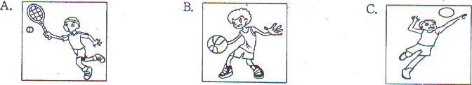
2. What is Jack's mother?
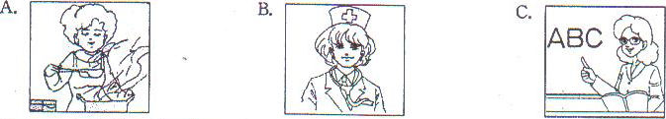
3. How much is the schoolbag?
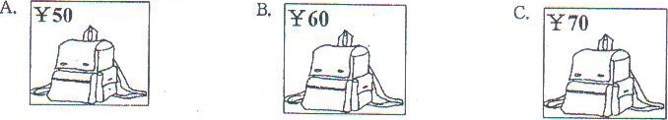
4. Which sign are the speakers talking about?
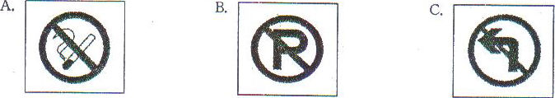
5. How does Sam feel?
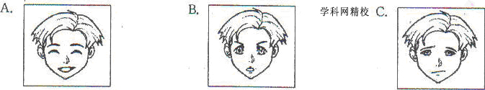
第二节；听长对话．回答问题。
听下面一段较长的对话，回答第6～7两小题。
6. Where does the woman want to go?
A. To a bank. B. To a cinema. D. To a hospital.
7. How long will it take the woman to go there by bus?
A. 5 minutes, B. 10 minutes. C. 15 minutes.
听下面一段较长的对话，回答第8～l0三小题。
8. Where does the conversation most probably take place?
A. In a boat. B. In a house C. In an office.
9. What does Sally take to David?
A. Photos. B. Camera. C. A ticket.
10. What do Sally and David think of the trip?
A. Boring, I3. Interesting. D. Dangerous.
第三节：听独白，根据内容．请从A、B、C三个选项中选择正确的选项完成通知。

NOTICE
Speaker: 11 , and American 12
Place: In the 13
Time: At 7:00, 14 evening
Topic: Travel experience in 15

11. A. Sara Jones B. Annie Smith C. Mary Black
12. A. writer B. reporter C. manager
13. A. gym B. library C. library
14. A. Wednesday B. Thursday C. Friday
15. A. Asia B. Africa C. America
二、单项填空 (本题有10小题，每小题l分；满分l0分)
请从A、B、C、D四个选项中选出可以填入空白处的最佳选项。
16. －Whose is _________ pen on my desk?
－It's Mary's.
A. a B. an C. the D. 不填
17. Please pick me up at the _________. My plane arrives at 8:00 am.
A. hotel B. airport C. museum D. theatre
18. Tom is very _________. He never cleans his room.
A. lazy B. active C. smart D. healthy
19. It isn't warm today, _________ the sun is shining.
A. or B. and C. because D. although
20. －May I use your calculator?
－Sorry, I left _________ at home.
A. it B. one C. this D. that
21. Most students like the teachers _________can understand them well.
A. who B. when C, what D. which
22. Let me _________ your phone number and I'll call you when I'm free.
A. cut down B. turn down C. look down D. write down
23. －Mike, why are you watching TV again?
－I _________ my homework.
A. finish B. finished C. have finished D. had finished
24. The fire last night destroyed many buildings. _________, no one was killed.
A. Actually B. Simply C. Luckily D. Immediately
25. －Oh, we’ve missed the 6’clock film.
－_________. It'll be on again in two hours.
A. Have fun B. Don't worry C. Sounds great D. You’re welcome
三、完形填空(本题有15小题，每小题l分；满分l5分)
阅读下面短文，掌握大意．然后从A、B、C、D四个选项中选出最佳选项。
Eric was standing in front of a large, gray house in the countryside. He had just been dropped off by his mum, who left after telling him that he was going to 26 the next twelve days there with no TV, no mobile phone and —worst of all —no 27 .
Just then, a man appeared 28 the gate of the house. When he saw Eric, he went up to him immediately. “I’m 29 you are Eric. Welcome to Camp Reboot," said the man proudly. "I'm Tony, the camp leader, but you will 30 me 'Sir'. Now you tell me 31 you're here."
Eric quickly replied, “My mum made me 32 !” When Tony looked angrily at him and did not say 33 , Erie realised his mistake and added, "Sir!"
"And do you know why your mother sent 34 here?" asked Tony.
“She thinks I spend too much time online － that I can’t live without the Internet… Sir,” answered Eric. "It's not just her opinion — it's the 35 ! Look at you—tired, unfit and certainly not getting 36 sleep. You're here because you think your world on the Internet is much 37 than the real world. But you're wrong! The real world has much more to offer. At Camp Reboot, you're going to go hiking, boating, rock-climbing and stay outdoors most of the 38 ." said Tony.
Eric's heart broke.
“But it's not going to be all fun and games," Tony continued. "We have rules here. 39 you break them, you'll never be sent home 40 ! Instead, you'll have to sweep the floor, wash the dishes or do an extra hour of exercise!”
“Oh, my God!" cried Eric. “What have you got me into, Mum?"
26. A. save B. keep C. show D. spend
27. A. radio B. camera C. recorder D. computer
28. A. at B. on C. in D. to
29. A. sad B. sure C. worried D. surprised
30. A. call B. make C. wish D. describe
31. A. what B. how C. why D. when
32. A. cook B. play C. come D. work
33. A. something B. anything C. everything D. nothing
34. A. it B. you C. him D. her
35. A. answer B. story C. truth D. excuse
36. A. short B. quick C. enough D. terrible
37. A. older B. darker C. poorer D. better
38. A. time B. life C. year D. journey
39. A. If B. Until C. Before D. While
40. A. loudly B. early C. slowly D. carefully
四、阅读理解(本题有15小题，每小题2分；满分30分)
阅读下面材料，从每题所给的A、B、C、D四个选项中选出最佳选顷。
A
Mr and Mrs Cheng often felt unwell. They went to see Dr Fang at least once a week. Dr Fang was always cheerful. He listened to Mr and Mrs Cheng carefully. Then he told them a joke:
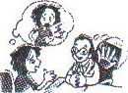
Yesterday a lady came nervously. She touched her arm, her leg and her stomach. "Doctor," she said, "when I touch these places, I feel a pain (疼痛). What’s the matter with me?" I told her, "Your finger is broken!"
Mr and Mrs Cheng laughed. They felt better and went home. The next week they visited Dr Fang again. He told them another joke:
Two days ago a man came to see me. He said he could see two of everything. When I asked him to sit on the chair, he asked me, “Which one?"
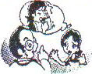
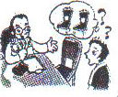
Mr and Mrs Cheng both laughed and went home felling better. A week later, the Chengs went to see Dr Fang again. He told them a new Joke:
Last week a lady told me that when she drank coffee, she got a pain in the head. I told her to take the spoon out before she drank it.
The Chengs laughed and left happily.

4l. In the first joke _________ parts of the body are mentioned.
A. two B. three C. four D. five
42. In the second joke something may be wrong with the man's _________.
A. arms B. eyes C. legs D. ears[
43. In the last joke the lady got a pain in the head when she _________.
A. saw a doctor B. heard jokes C. sat on a chair D. drank coffee
B
Zoos are places where different kinds of animals are kept and shown for the public. At most modern zoos people can see, smell and hear animals in their natural way. Some zoos even have “friendship farms" where people can touch some of the animals. Here are four reasons why people need zoos.
Firstly. zoos educate people about animals and their natural environment. They give interesting information about each animal, such as where it comes from and how it lives. Special teachers at the zoo help children understand more about the animals. Trained guides show visitors around the zoo.
Secondly. zoos are working hard to find out more about animals. New knowledge leads to improved ways of looking after animals in the zoo, and better understanding of the same animals in the wild.
Thirdly. zoos play a part in protecting animals and stopping them from disappearing. Zoos work together with each other to help the animals in danger. For example, gorillas (大猩猩) from Taronga Zoo were sent to live with gorillas at the Melbourne Zoo in the hope that they would give birth to babies.
Finally. zoos are important for people's enjoyment. People enjoy getting close to animals without having to cross the plains (平原) of Africa or climb the mountains of China. In the past, animal shows were common in zoos. Visitors were excited by monkeys in human clothes, and they even took rides on elephants or horses. However, today people prefer to see animals behaving naturally.
So a modern zoo is a place where animals are well eared for.
44. Special teachers at the zoo _________.
A. show visitors around the zoo B. ride elephants or horses
C. look after animals in danger D. help children know about animals
45. From the passage we know _________ were sent from Taronga Zoo to the Melbourne Zoo.
A. horses B. gorillas C. monkeys D. elephants
46. According to Paragraph 5, visitors to the zoos enjoy themselves because they _________.
A. can get close to animals B. prefer to cross plains
C. like climbing mountains D. can organize animal shows
48. Which of the following is NOT TRUE according to the passage?
A. Modern zoos have improved ways of looking after animals.
B. At modern zoos people like to see animals behaving naturally.
C. At modern zoos baby animals are usually born on the "friendship farms".
D. Modern zoos educate people about animals and their natural environment.
C
Do you know how important it is to have breakfast? A study of 2,000 teenagers in the US showed that eating breakfast daily is helpful to young people.
According to the study, teenagers who eat breakfast weigh around 5 pounds less than teenagers who do not. Although they take in more calories (卡路里) in the morning, they are more active during the day because they have more energy. This means they burn more calories than non-breakfast eaters. The breakfast does not even have to be very healthy, as eating anything is better than nothing.
The study also showed that eating breakfast keeps teenagers feeling full for longer, so they will not eat too many snacks (零食) later in the day. This is good news as most popular snacks, like sweets and potato chips, are usually unhealthy and full of calories.
Another big advantage of eating breakfast is that it helps teenagers do better at school. This is because it gives them more energy to keep their attention in class.
What's more, a study in the UK showed that adults (成年人) who eat breakfast daily put on less weight and also perform better at work.
Whatever your age is, take time to have breakfast every day.
48. The underlined sentence in Paragraph 2 means that _________.
A. teenagers should eat something for breakfast
B. breakfast helps teenagers do better at school
C. breakfast must be healthy with lots of calories
D. the energy makes teenagers active the whole day
49. Having breakfast daily makes the teenagers _________.
A. eat fewer snacks B. pat on more weight
C. relax themselves D. burn less calories
50. The passage is mainly about _________.
A. the importance of snacks B. how the adults perform at work
C. the advantages of having breakfast D. losing weight without breakfast
51. We can probably read this passage in a (an) _________.
A. story book B. health magazine
C. movie poster D. instruction book
D
For thousands of years, people have used plants to make medicines. They used different parts of the plants—the roots, the leaves, the flowers, and the bark (树皮). Today, doctors have rediscovered more medicinal values (药用价值) of some plants. Let's look at some examples.
Foxglove is a common plant. People have used it to make the heart slow down. Recently scientists have developed another drug from it. This new drug helps prevent other heart problems.
In some areas, malaria has been a problem. Scientists have learned that the bark of a South American tree, the cinchona, can be made into a drug to prevent malaria. For a long time, the Chinese have known that a special plant, wormwood, can also fight malaria. Scientists have been working with it to develop new drugs against malaria.
In Germany, some scientists studied garlic (大蒜) for four years. They found that it helps prevent the build-up of plaque (血小板) because too much plaque is bad for health. This very common plant continues to be studied.
As we know, there are about 250,000 kinds of flowering plants in the world. Scientists have only studied little more than one percent of plants for their medicinal value. Maybe medicines for AIDS and cancer will be made from the other 99 percent.
52. What can foxglove be used for?
A. Studying plants. B. Building up the plaque.
C. Treating AIDS and cancer. D. Preventing heart problems.
53. What does the underlined word "malaria” in Paragraph 3 refer to (指的是)?
A. A drug. B. A scientist C. An illness. D. An animal.
54. How many plants are mentioned in the passage?
A. 3. B. 4. C. 5. D. 6
55. Which of the following is the best title for the passage?
A. Past and future B. Plants and medicine~
C. Health and illness D. Scientists and doctors
卷Ⅱ
五、词汇运用(本题有l5小题，每小题l分；满分15分)
A.根据短文内容和所给汉语提示，写出短文空白处各单词的正确形式。每空限填一词。
Dear Father Christmas,
My name is Samuel. I am 56 (六) years old. I live in New York. Christmas is coming and I know you are going to visit New York 57 (不久). I am a very good boy this year, so I hope you will 58 (拿来) me lots of presents。
I have four wishes. First, I want a new bicycle because my old one is too 59 (小的) for me now. The second thing I want is a 60 (篮球). You can believe me that I won't play with it in my bedroom. I also want ten 61 (盒子) of chocolates for Christmas. Don't worry, Father Christmas, I will brush my 62 (牙齿) every day! Finally, I hope you will give me many colour pencils because I like 63 (绘画). Will you put them in my Christmas stocking on Christmas Eve? Do you like 64 (牛奶) and cookies? Will I put them 65 (在……下面) the Christmas tree for you?
Love
Samuel
B.用方框中所给单词的适当形式填空，使句子通顺、正确。每个单词限用一次。

her below allow obey peaceful
66. In most schools students are not ____________ to eat in class.
67. On the top of the mountain we could see the whole city ____________ us
68. She returned home after work and made a cup of coffee for ____________.
69. Their children were sent to school, and they had a ____________ afternoon.
70. Peter's parents are strict with him and he has to ____________ them without question.
六、任务型阅读(本题有5小题，每小题l分；满分5分)
阅读下面五位学生对校服的看法，选出他们喜欢的校服。

________ 71. Tony | It is important to wear the most comfortable clothes at school. My friends and I all prefer T-shirts in summer.
________ 72. Jimmy | We do a lot of sports at school, so it is a good idea to wear clothes that are good for sports.[
________ 73. Susan | Iris getting warmer and warmer. A dress is a perfect choice. Girls look nice in dresses.
________ 74. Johnson | Our school has a respect for the traditional Chinese culture. So why not get all the students in Tang Zhuang?
________ 75. Emma | We'll have many activities in the coming months. So a suit (a set of clothes) will be the one as we need to dress up for these activities.

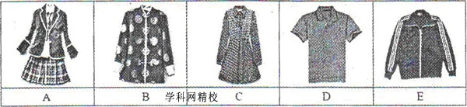
七、书面表达(本题有1小题，满分20分)
76.“中学生是否可以在校使用手机？”你班就此话题进行了讨论。请你根据以下记录表写一篇短文，陈述讨论结果，并发表你的观点。

Opinions | Reasons
Mobile phones should be used | surf the Internet for information  play games for enjoyment  …
Mobile phones shouldn’t be used | send messages in class  use public phone school  ….

要求
①短文应包括表中所给信息；②补全表中的理由，同时发表你的观点；③文中不得出现与你身份相关的信息；④词数：80一100个，开头已给出，不计入总词数。
Recently we held a discussion about whether the students should use mobile phones at school or not. Some of us think _____________________________________________________________
_______________________________________________________________________________



