试卷类型：A
二0一二年 初 中 学 业 考 试
英 语 试 题

注意事项：
1.本试题分第Ⅰ卷和第Ⅱ卷两部分。第Ⅰ卷 8页为选择题，75分；第Ⅱ卷 4页为非选择题，45分；共120分。考试时间为120分钟。
2.答第Ⅰ卷前务必将自己的姓名、考号、考试科目涂写在答题卡上。考试结束，试题和答题卡一并收回。
3.第Ⅰ卷每题选出答案后，都必须用2B铅笔把答题卡上对应题目的答案标号（ABCD）涂黑。如需改动，必须先用橡皮擦干净，再改涂其它答案。

第Ⅰ卷 （选择题， 共75分）

一、听力测试（共20小题，计20分； 每小题约有10秒钟的答题时间）
(一) 录音中有五个句子，每个句子听一遍，然后从每小题A、B、C中选出能对每个句子做出适当反应的答语。（录音播放前每小题约有5秒钟的读题时间)
1. A. I don’t know. B. Sorry, I have no watch. C. Ask others.
2. A. Yes. B. No, not at all. C. It doesn’t matter.
3. A. Nice to meet you, Mike. B. Hi! I’m Mike. C. How are you?
4. A. Good luck. B. Oh. It's nothing. C. Thank you.
5. A. It’s a pity! B. Good idea！ C. Why?
（二）录音中有五组对话，听对话两遍后，从每小题A、B、C中选出能回答所给问题的正确答案。（录音播放前每小题约有5秒钟的读题时间)
6. What is the boy doing in the evening recently?
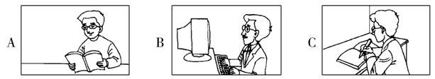
7. What’s the weather like today in the woman’s opinion?
A. Hot B. Cool C. Cold
8. Why isn’t Dale here?
A. He is ill.
B. He is preparing for the sports meet.
C. He had traffic accident.
9. How can the boy get to understand the English news according to the woman?
A. Listening to Special English first.
B. Remembering more words.
C. Listening to Special English first and remembering more words.
10. Who is the girl?
A. The boy’s teacher. B. The boy’s classmate. C. The boy’s sister.
（三）录音中有一段对话，听对话两遍后，从每小题A、B、C中选出能回答所给问题的正确答案。（录音播放前约有25秒钟的读题时间）
11. Where is the woman talking?
A. In a classroom. B. In a cinema. C. At home.
12. When does the boy want to see a movie?
A. Tomorrow. B. This Saturday. C. This Sunday.
13. Which movie may the boy watch at last?
A. Black September. B. My father’s birthday C. Home Alone.
14. What kind of movies does the boy like?
A. Comedies. B. Thrillers. C. Documentaries.
15. What can we get from the dialogue?
A. The tickets are 15 yuan.
B. The movie starts at 8:00 in the morning.
C. The boy thinks the tickets are too expensive.
（四）录音中有一段独白，听独白两遍后，从每小题A、B、C中选出能回答所给问题的正确答案。（录音播放前约有25秒钟的读题时间）
16. Where is Susan Rozgony from?
A. America B. Australia C. England
17. Why does Susan like singing?
A. It gets her clever.
B. It makes her relaxed.
C. It gives her a chance to show herself.
18. How long does Susan usually spend on math every day?
A. Two hours. B. Four hours. C. Twelve hours.
19. Who is Frank?
A. Susan’s brother. B. Susan’s father. C. Susan’ s dog
20. What kind of a person is Susan?
A. Nervous. B. Outgoing. C. Quiet.

二、单项选择 （共15小题，计15分）
从每小题A、B、C、D中选出一个能填入句中空白处的最佳答案。
21. Here is _______ bike my uncle sent me last week. I believe it’s ________ fantastic one?
A. a; a B. the; the C. the; a D. a; the
22. After school, I had a long _______ with my teacher about my study.
A. talk B. word C. speech D. story
23. I didn’t buy the second-hand book because the seller wanted ______ money than I had expected.
A. less B. least C. most D. more
24. －Tell us something about Canada, OK?
－I’m sorry. _________ Jack _________ I have ever been there.
A. Either; or B. Not only; but also
C. Both; and D. Neither; nor
25. Rock music may ________ nice to young people, but most old people can’t stand it.
A. hear B. sound C. look D. listen
26. I really enjoyed your speech, ______ there were some parts I didn’t quite understand.
A. because B. for C. until D. though
27. －_______ you _______ Jeremy Shu-How Lin?
－Yes. The once-nameless young man became a basketball hero suddenly.
A. Did; hear B. Do; listen to C. Have; heard of D. Have; listened to
28. She has many hobbies. Her after-work life is ________ .
A. lonely B. colorful C. empty D. dull
29. －_____ your brother speak Japanese?
－Yes, he has learnt it in Tokyo for three years.
A. Should B. Must C. Can D. May
30. I don’t think fast food is good for our health, so I _______ go to MacDonald.
A. seldom B. always C. usually D. often
31. －I called you this morning, but nobody answered it.
－Oh, we _____ some running in the park.
A. are doing B. were doing C. have done D. did[
32. －Never ________ today’s work till tomorrow.
－Yes. It’s a good habit.
A. put off B. put on C. put up D. put down
33. I gave up the piano lessons because I have so much homework to do, but it’s _______ my own wishes.
A. in B. on C. for D. against
34. －Do you enjoy ______ a volunteer?
－If you want _______ this, you’d better join us.
A. being; knowing B. to be; knowing C. being; to know D. to be; to know
35. These animals are in danger. We should think ________ to protect them.
A. what can we do B. what we can do C. how can we do D. how we can do
三、完形填空 (共10小题，计10分)
阅读下面的短文，掌握其大意，然后从短文后各题所给的A、B、C、D四个选项中，选择最佳选项。
Last July, my 12-year-old car died on California's Santa Freeway. It was an hour before sunset, and I was 25 miles from home. I couldn't reach anyone to pick me up, so I 36 to take a bus. Not knowing the routes(线路), I thought I'd just go east.
A bus stopped. I got 37 and asked the driver how far she was going. “Ten more miles,” she said. There was 38 bus I could take from there. This clearly was going to be a long night.
I got off at the end of the route and she told me which bus to look 39 . After waiting 30 minutes, I began to think about a very expensive taxi 40 home. Then a bus came up. There was no lighted number above its windshield (挡风玻璃). It was out of service, but the door opened. It was the same driver.
“I just can't leave you here,” she said. “This isn't the nicest place. I will take you home.”
“You will drive me home on the bus?” I asked in 41 .
“No, I will take you in my car,” she said.
“It's a long way.”
“Come on,” she said. “I have nothing 42 to do.”
She began telling me a story 43 we drove from the station in the car. A few days 44 , her brother had run out of gas (汽油). A kind man picked him up, took him to a service station and then back to his car. “I'm just passing the kindness along,” she said.
When I offered her money as a thank-you, she refused. “Just do 45 nice for somebody. Pass it along,” she said.
36. A. agreed B. decided C. found D. used
37. A. away B. down C. on D. off
38. A. another B. same C. every D. each
39. A. at B. into C. after D. for
40. A. ride B. ticket C. guide D. driver
41. A. agreement B. surprise C. heart D. order
42. A. hardly B. probably C. else D. everywhere
43. A. so B. because C. before D. as
44. A. later B. earlier C. more D. missing
45. A. something B. everything C. anything D. nothing

四、阅读理解（共15小题，计30分）

阅读下列材料，然后从每小题A、B、C、D四个选项中选出能回答所提问题或完成所给句子的最佳答案。

A
Our Spring Festival!
The Spring Festival is coming! How do you celebrate with your family? Keep the happy moments with a camera, send the photos and stories behind them to Teens. Share your happiness with everyone in the Spring Festival Contest.
Time: January 16, 2012—March 1, 2012
Size of the photos: 5 or 6 inches (英寸).
Stories to the photos: at least 80 words corresponding to (和…相符) the photos
Prize: 400-yuan MP4 for first prize; 100-yuan U-disc for second prize; April issues of Teens for third prize
Address: 15, Huixindongjie, Zhaoyang District, Beijing
Email: junior@teens.com.cn
Phone: 010-64798012

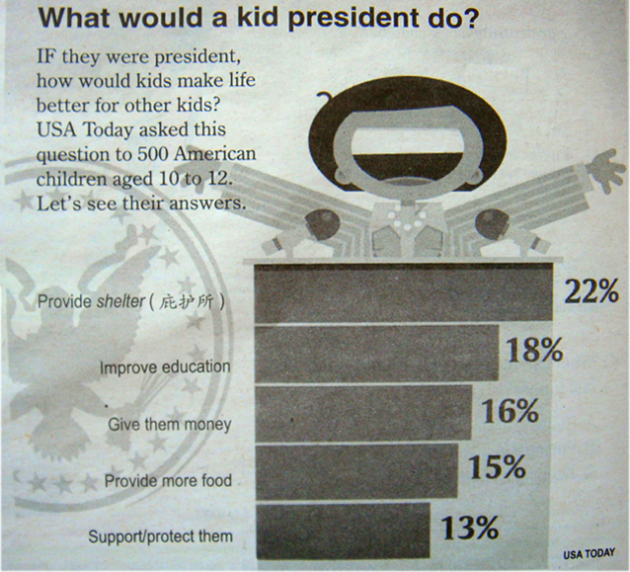

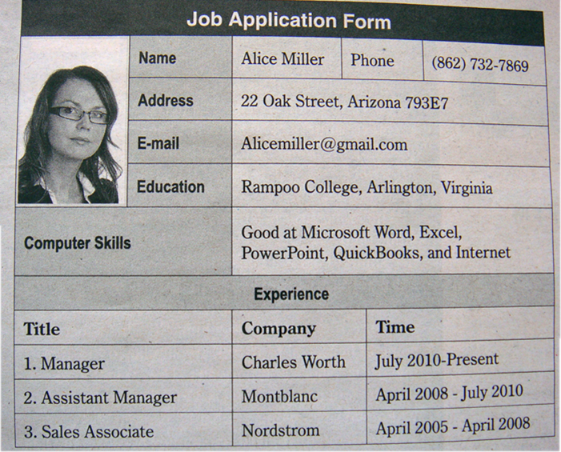

46. If you want to win a prize by taking photos, you can send your work to ________ .
A. Alicemiller@gmail.com. B. USA TODAY.
C. 15, Huixindongjie, Zhaoyang District, Beijing. D. 22 Oak Street, Arizona 793E7.
47. __________ American kids asked would make life better for other kids by improving education.
A. 80. B. 90. C. 75. D. 110.
48. How long has Alice Miller worked at Nordstrom?
A. Two years. B. Three years. C. Five years. D. Half a year.
49. Alice Miller is working at ___________ .
A. Nordstrom B. Montblanc C. Rampoo D. Charles Worth
50. Which of the following is NOT right?
A. You can call 862-732-7869 to get information about a contest.
B. “What Would A Kid President Do?” is a survey.
C. Alice Miller is a businesswoman.
D. You will get an MP4 if you win first prize in the Spring Festival Contest.
B
One afternoon, in Paris, I took a trip to an art museum while waiting for my husband to finish a business meeting. I was looking forward to a quiet view (看) of some great paintings of excellent artists.
A young couple looking at the paintings in front of me were talking non-stop. I watched them a moment and decided she was doing all the talking. In fact, I was surprised at this man for putting up with her everlasting speech. Bored by their noise, I moved on.
I met them several times as I moved through those rooms of art. Each time I heard her voice, I moved away at once.
I was standing at the museum gift shop buying some cards when the couple walked to the exit (出口).
“He’s a brave man,” said the shop assistant. “Most of us would give up if we were blinded at such a young age. But he and his wife come in whenever there’s a new art show.”
It explained the non-stop talk! A sudden sense of shame came to my heart for what I was thinking just now. “But what does he get out of the art?” I asked.
“His wife describes each painting so he can see it in his head.”
At that moment I realized what is patience, courage and love. I saw the patience of a young wife describing paintings to a person who can’t see and courage of a husband who would not allow blindness change his love towards art. And I felt the love shared by the two as I watched them walking away holding each other’s hands.
51. How did the writer feel in the beginning when hearing the woman’s talking?
A. Surprised B. Bored C. Excited D. Happy
52. What can we infer (推断) from the underlined sentence in Paragraph 1?
A. The writer was waiting for somebody.
B. The writer was a silent person.
C. The writer was looking for some great paintings.
D. The writer wanted t to enjoy some great paintings quietly and carefully.
53. The woman kept talking while she and her husband were enjoying the art show because ___________.
A. she was too excited to keep silent
B. she preferred talking to listening
C. she had to explain everything to her blind husband
D. she liked to show off in front of others
54. What did the writer think of the woman at last?
A. The woman was too noisy. B. The woman was patient and loving.
C. The woman was blind. D. The woman was brave.
55. The passage mainly shows us ___________.
A. patience, courage and love B. how to watch paintings
C. how art changed people’s life D. a trip
C
Today I went to Sam’s school in the UK. It was really different from my school in China.
Girls wore grey skirts and white shirts, boys wore grey trousers, and everyone wore the school tie.
Some of Sam’s lessons were a bit strange for me. We were reading Shakespeare in the English lesson, and there were quite some old words like “thou” and “thee” to mean “you”. In history we studied 20th Century China. It was strange hearing a foreign side of history—and hearing English people trying to say all our Chinese names!
Classes were also a lot more relaxed than in China. Teachers were called “sir” or “miss”, everyone shouted answers and raised their hands in classes. It was more like a debate than a class. A bell rang at the end of each lesson and everyone jumped up to go to the next class.
At break we bought potato chips and cookies in the dining room. Lunch was later than in China—at 1 o’clock. We had big plates of pie with carrots. For dessert there was hot sweet rice called rice pudding.
It was good that I’d had an excellent lunch, because at Sam’s school Monday afternoons are taken up with sports.
I played my first game of netball—a bit like basketball, but with some differences. Luckily I’d had a quick look in the rule book before I tried to join in the game.
Sam’s weekly schedule of classes
 | Monday | Tuesday | Wednesday | Thursday | Friday
9:00-9:30 | Math | English | Free period | French | History
9:45-10:15 | Math | English | French | French | History
10:20-10:50 | Biology | Free period | French | Biology | Biology
10:50-11:20 | Break | Break | Break | Break | Break
11:20-11:50 | History | Physics | Biology | Chemistry | Physics
11:55-12:25 | History | Physics | Biology | Math | Music
12:30-13:00 | English | Math | History | Math | Music
13:00-14:00 | Lunch | Lunch | Lunch | Lunch | Lunch
14:00-14:30 | PE | Chemistry | Chemistry | Free period | PE
14:35-15:05 | PE | Chemistry | English | English | PE
15:10-15:40 | PE | Music | Physics | English | PE

56. Paragraph 2 shows that ___________.
A. they wear uniforms in Sam’s school
B. lessons are different between schools in China and the UK
C. there is a break of 30 minutes every day in the school
D. sports take up much time in Sam’s school

57. The underlined word debate in Paragraph 4 means ___________.

A. fight B. exam C. discussion D. suggestion

58. What do they have for lunch at Sam’s school?

A. Pie and hot sweet rice. B. Potato chips.

C. Cookies. D. Carrots.

59. How many hours do they have for foreign language study?

A. 4 hours. B. 2 hours. C. 3 hours. D. 6 hours.

60. What’s the best title for the passage?

A. Relaxed Classes in the UK B. Clothes, Food and Sports in a UK School

C. Strange Lessons in Sam’s School D. A Day in Sam’s School

试卷类型：A
二0一二年 初 中 学 业 考 试
英 语 试 题
第Ⅱ卷 （非选择题， 共45分）
注意事项：
1、第Ⅱ卷共4页，用钢笔或圆珠笔将答案直接答在试卷上。
2、答卷前将密封线内的项目填写清楚。
题 号 | 五 | 六 | 七 | 总 分
分 数

得 分 | 评卷人

五、 词汇运用（共两节，计20分）

第一节 单词拼写 根据首字母或汉语提示，写出下列句子中单词的完全形式。（共10小题，计10分）
61. There are too many p__________ in a bus and the air in it is dirty. I choose to travel by train.
62. I want to see English movies to improve my English, but they speak too q____________ for me to catch their meaning.
63. Thursday is the f__________ day of a week.
64. Get up early, go out for some f__________ air and enjoy a healthy life.
65. I’m very upset because everyone else in my class was invited to the party e___________ me. I feel so lonely.
66. A bite of China is a program on CCTV introducing food ____________ (文化)of China.
67. Good sleep helps the body and brain grow and ______________ (发展).
68. If you like shopping, Xidan will be your ____________(最喜欢的)place.
69. Four suggestions of students from Beijing National Day School were ____________ (接受)and reported to NPC during the NPC and CPPCC meetings in March.
70. I’ve had some most _____________ (美味的) food in that restaurant.
第二节 用方框内所给单词的适当形式填空。（共10小题，计10分）

happy, close, angry, parent, listen, make, if, long, but, important

Are you the only child in the family? If so, you are the most 71 in your family. 72______ are the closest people to you in the world. But a lot of middle school students have a problem. They feel they're not as 73 to their parents as before. They even think their parents are unfair to them.
Some students complain that their parents say a lot to them, but never 74 to them. Some of them even say it75 .
“My parents don't allow me to play computer games, 76 other classmates are doing that”.
Others say, when they're 77 phone calls to friends, their parents like to ask if they're speaking to a boy or a girl. These make them very 78 . Some students even decide to leave home. But they don't know running away may bring them some more problems. Show your parents you're growing up. Then they'll feel you're no 79 a small child.
80 you follow the advice, you'll have a happy life and never think of running away.
得 分 | 评卷人

六、阅读表达 (共5小题，计5分)

阅读短文，根据要求完成下面各小题。
As teenagers, you have many dreams. These dreams can be very big, such as winning the Nobel Prize, or they can be small. You may just want to become one of the ten best students in your class.
Once you find a dream, what do you do with it? Do you ever try to make your dream true?
Follow Your Heart by Australian writer Andrews tells us that making our dreams true is life’s biggest challenge (挑战).
In fact, everyone can make his dream come true. The first thing you must do is to remember what your dream is.
Don’t let it leave your heart. Keep telling yourself what you want. Do this step by step and your dream will come true faster because a big dream is, in fact, many small dreams.
You must also never give up your dream.
There will be difficulties on the road to your dreams. But the biggest difficulty comes from yourself. You may think you’re not very good at some school subjects, or it is impossible for you to become a writer. These kinds of thoughts stop you from getting your dream, the book says.
You need to decide what is the most important. Studying instead of watching TV will lead to better exam results, while saving five yuan instead of buying an ice cream means you can buy a new book. As you get closer to your dream, it may change a little. This is good as you have the chance to learn more skills and find new interests.
81. Translate the sentence underlined in paragraph 7 into Chinese.

___________________________________________________________________________
82. Find out the sentences from the passage that stand for “the biggest difficulty comes from yourself”.

___________________________________________________________________________

___________________________________________________________________________
83. What should you do if you want to make your dream come true? (至少两条)

__________________________________________________________________________

__________________________________________________________________________
84. What’s the main idea of the last paragraph?

_____________________________________________________________________________

85. 请给短文拟定一个适当的英文标题。

__________________________________________________________________________
得 分 | 评卷人

七、 写作（共两节，计20分）

第一节 根据所给汉语完成句子。 (每空一词)（共5小题，计10分）
86. 飞机起飞时天正在下着大雨。
It was raining hard when the plane __________ ___________ .
87. 学习方面老师对我们要求严格。
Our teachers are _________ ___________ us in study.
88. 她已经足够大了，可以自主做出决定。
She is old _____________ ___________ make her own decision.
89. 安徒生如此闻名，以至于几乎每个小孩都能说出一两个他的童话作品。
Andersen is __________ famous ___________ almost every child can name one or two of his fairy tales.
90. 为何不给她买个相机作为生日礼物呢？
___________ ____________ you get her a camera as a birthday present?
第二节 书面表达 （共1题，计10分）
三年的初中生活就要结束，崭新的高中学习即将到来。回顾过去，你一定有许多成功的喜悦与失利的遗憾；展望未来，你肯定有美好的憧憬和实实在在的打算。请你以“Unforgettable Memories ”为题，给英文报纸21st Century “青春校园”栏目写一篇80词左右的征文。
注意：1. 内容要包含对过去的回忆（学业有成、爱好特长、师生情谊以及最大的遗憾）和对未来的憧憬。
2. 文中不要出现你的真实姓名和学校名称；
3. 文章的开头已给出，不计入总词数。

Unforgettable Memories
How time flies! Three years passed

________________________________ _____________________________________________

_______________________________________________________________________________

_______________________________________________________________________________



