2012年福建省泉州市初中毕业、升学考试
英语试题
第一卷
第一部分 听力考查 (30分)
第一节 听句子：根据你所听到的句子，选择恰当的答语。(句子读两遍) (5分)
1, A. Tomorrow. B. New York. C. A ruler.
2. A. Half past eight. B. Three days. C. In the lab.
3. A. It's a pity. B. You're right. C. Thank you,
4. A. I'd love to. B. Bad luck! C. Well done!
5. A. It's a nice place. B. By subway. C. About five kilometers.
第二节 听对话：(25分)
(A) 从A、B、C三幅图画中选出符合对话内容的图画。(对话读两遍) (6分)
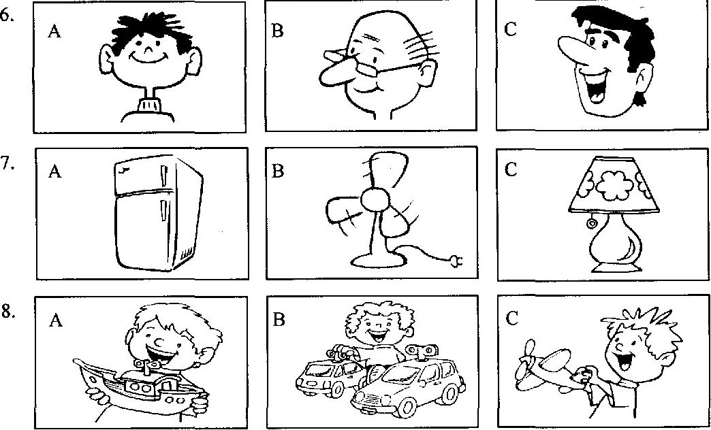
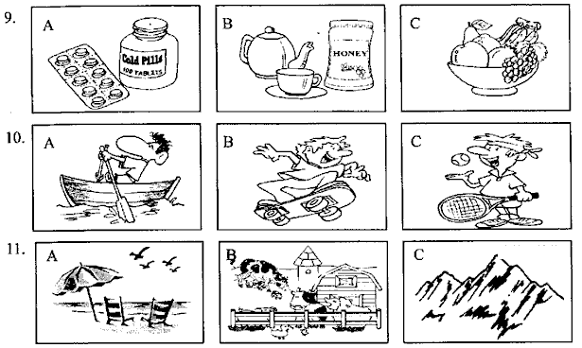
(B) 根据你所听到的对话，选择正确的答案。(对话读两遍) (14分)
听第一段对话，回答第l2、13小题：
12. How's the weather?
A. Cold. B. Warm. C. Hot.
13. What would the man like to eat？
A. Grapes. B. Watermelon. C. Strawberries.
听第二段对话，回答第l4、15小题：
14. The man is looking for a book about ________.
A. famous people B. places of interest C. Chinese culture
15. What's his son fond of?
A. Sport. B. Music. C. Science.
听第三段对话，回答第l6、17小题：
16. Why is Jane sad?
A. She failed the exam. B. She misses her parents. C. She has no friends.
17. They decide to ________ together.
A. take a walk B. fly a kite C. have a picnic
听第四段对话，回答第l8、19小题：
18. The man wants to book a room with ________.
A. a double bed B. a single bed C. two single beds
19. How much does he have to pay in total?
A. ￥180. B. ￥360. C. ￥540.
听第五段对话，回答第20、21小题：
20. What housework does Mike do?
A. Looking after the dog. B. Cleaning the house. C. Washing clothes.
21. Mike's father is good at ________.
A. painting B. fishing C. cooking
听第六段对话，回答第22、23小题：
22. When did Amy start her new job?
A. In May. B. In April. C. In March.
23. What does Amy do?
A. A nurse. B. An engineer. C. A secretary.
听第七段对话，回答第24、25小题：
24. Bill won the ________ place in the skiing competition.
A. first B. second C. third
25. How does Bill feel about skiing?
A. Difficult but interesting. B. Dangerous but exciting. C. Easy but boring.
(C) 听一段对话，回答第26-30小题。(对话读三遍) (5分)
26. The woman is Jenny's ________.
A. aunt B. mother C. sister
27. Where did Jenny get lost?
A. In the supermarket. B. In the hotel. C. At the railway station.
28. What can we know about Jenny?
A. She is fat. B. She has long hair. C. She has black eyes.
29. Jenny takes a toy ________ with her.
A. elephant B. rabbit C. bear
30. Where does Mrs. White live?
A. At 58 Market Street. B. At 48 Banker Street. C. At 38 Center Street.
第二部分选择填空 (35分)
(A) 单项选择：从每小题A、B、C三个选项中，选出能填入空白处的最佳答案。(15分)
31. －Excuse me. What's the ________ usually used for?
－It's used for protecting people from the rain.
A. raincoat B. mirror C. shelf
32. －Who gets up ________ of you all in the dormitory, Tony?
－Jimmy does.
A. early B. earlier C. earliest
33. －There's ________ important in today's newspaper, isn't there?
－Sorry, I don't know. I haven't got the paper yet.
A. nothing B. something C. anything
34. －Let's go to see the stamp collection show.
－_________
A. Good idea! B. Don't worry. C. What a shame!
35. －Is that girl in red Sally?
－No, it ________ her. She has gone to Hong Kong.
A. may be B. must be C. can't be
36. －I think everyone must do his best to ________ pollution.
－If so, there will be a good future for people of tomorrow.
A. stand B. stop C. hide
37. －We'd better not read ________ the sun.
－I agree. It's bad for our eyes.
A. in B. with C. under
38. － Would you like some eggs, Judy?
－________. I don't like them at all.
A. I'm not sure B. All right C. No, thanks
39. －I hear Michael never tells a lie.
－That's right. He is an ________ boy.
A. active B. honest C. outgoing
40. －I'll take part in the boys' 200-meter race this afternoon!
－_______
A. Never mind. B. Of course not. C. Good luck to you!
41. －Why are you standing here, Mrs. White?
－I'm waiting for my son. He ________ back from school.
A. hasn't come B. won't come C. doesn't come
42. －I lost my bike yesterday and had to walk home.
－________.
A. It doesn't matter B. It's a pleasure C. I'm sorry to hear that
43. －What shall we do next?
－Take the advice ________ is given by Dr. Bloch.
A. who B. which C. whose
44.－Pardon? I didn't catch ________.
－I said the book sold very well in our school.
A. what you said B. where you would go C. who you talked about
45. －Can you tell me how to use the digital camera?
－ ________. Let me have a look.
A. No way B. No problem C. Forget it
(B) 完形填空：从每小题A、B、C三个选项中，选出能填入空白处的最佳答案。(10分)
Today, I'll talk about the problems we have these days. The problems of dogs and the objects falling from windows are getting 46 . We have received a lot of letters 47 such problems, so it's time to work out these problems.
Some dogs aren't taken good care of, and they 48 make mess (粪便) on roads and in gardens. This makes our community dirty. I'd like to tell the dog-owners that 49 behavior is too bad, and they are always making people feel unhappy.
Some people throw rubbish out of the 50 . It's dangerous because falling objects may hurt 51 . You know, it is against the law. We should 52 a notice to teach people not to do so. If it's found, we'll record the names and 53 of those people. Then, a written warning will be sent to their homes and they will 54 by law.
A safe and comfortable living environment is important to us. 55 we try our best to care for our community, it will be a good place to live in.
46. A. easier B. worse C. better
47. A. about B. except C. without
48. A. busily B. suddenly C. freely
49. A. his B. their C. our
50. A. windows B. doors C. cars
51. A. other B. the other C. others
52. A. put up B. look up C. put away
53. A. hobbies B. addresses C. experiences
54. A. punish B. be punishing C. be punished
55. A. If B. Before C. Although
(C) 口语运用：根据对话内容，从方框中选出能填入空白处的最佳选项，补全对话。(10分)
A: Hello!
A. See you then.
B. This is Wang Wei,
C. Turn left at the traffic lights,
D. May I speak to Mr. Brown?
E. But where are you now?
B: Hello! 56
A: Speaking. Who's that?
B: 57 a postman from EMS. Here is a package (包裹) for you. Could you tell me the way to your home?
A: 58
B: I'm close to Shuren Bookstore, Zhongshan Road.
A: Oh, I see. Go along Zhongshan Road until you get to Xinhua Street. 59 and you'll see many apartment buildings on your right. I live in Apartment 309, Building 8.
B: OK. 60
A: See you.
第三部分 阅读理解 (45分)
(A)
In Japan, the latest time-saving invention is a dog-washing machine. Dog owners can buy one for their dogs. They can save time by putting their dogs in the machine and then 33 minutes later, a clean, fresh-smelling dog comes out.
The washing includes a shampoo (洗发), rinse (冲洗) and blow-dry. Sales of the dog-washer are increasing. The machines save a lot of money for pet owners. However, it's bad news for pet hospitals because they are losing many customers.
The washing machine is very safe. Tests showed that dogs enjoyed the wash and were very happy when the blow-dryer started working. The makers of the machine say it's very safe and does not harm dogs in any way.
One dog-owner, Michiko Kobayashi, loves her new machine. She said her dog was happy, too. Michiko explained to the reporters, "Before I bought my washer, I only took my dog to the pet hospital a few times a year. Now, I wash her every week and she looks great. I also save a lot of money."
根据短文内容，判断下列句子是否正确，对的涂(A)，错的涂(B)。(10分)
61. The dog-washer is used to clean dogs.
62. The invention is good news for pet hospitals.
63. Tests showed dogs enjoyed blow-dry very much.
64. Neither Michiko nor her pet dog likes the new machine.
65. The dog-washer can help dog owners save time and money.
(B) (C)两篇 根据短文内容，从每小题A、B、C三个选项中选出一个最佳答案。(20分)
(B)
Do you have your own ideas about spending money? If no, now it's a great time to learn how to spend it. Follow the steps below when you are considering, buying something you want.
Step 1 How much do you really want it?
Seeing a $25 gum ball (口香糖球) machine, Ben wanted it at first. But after thinking about it, he decided it would be exciting only for a day or two. "... Besides, it's impossible for me to chew (嚼) much gum." he thought for a long time and then went away.[
Step 2 Do you still want it a week later?
If you really want the thing very much, try to wait for some time to see how strong the desire (欲望) is. This way works for grown-ups, too!
Step 3 How will you pay for it?
After the first two steps, Ben found he really wanted a toy pirate ship, but it cost $50. He had $22 in his pocket and got $1.50 a week from his parents. It would take Ben 19 weeks to save enough money to get the ship.
Step 4 Are there ways to make the money?
Ben agreed to wash the downstairs windows at $2 each. So he got $10 for himself.
Step 5 Can you get it cheaper?
After deciding to buy it, it's necessary for you to look for less expensive ways to buy it: search for what you want on the Internet, in shops and flea (跳蚤) markets. Sometimes you can find the same thing at much lower price.
If these suggestions work well, they can save you a lot of money. You will be a real smart shopper.
66. What did Ben do about the gum ball machine?
A. He bought it at once. B. He gave it up right away. C. He gave it up finally.
67. How many downstairs windows would Ben wash if he wanted to get $12?
A. Five. B. Six. C. Ten.
68. Why do people search for the same things online, in shops and flea markets?
Because ________.
A. they may find wonderful ones B. they just do it for fun
C. they may find them at lower prices
69. If you still want an iPhone 4s in two weeks, you should consider ________.
A. Step Three B. Step Two C. Step One
70. The passage is mainly about suggestions on how to ________.
A. make lots of money B. spend and save money C. pay for things
(C)
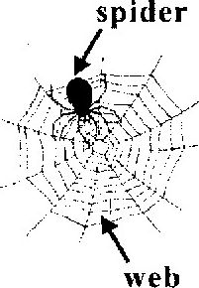
There are over 37,000 known species (种) of spiders in different shapes and sizes in the world. The largest spiders live in the rain forests of South America and are known as the "bird-eating" spiders. These spiders can grow up to 28cm long and they eat small birds. The smallest spiders are from Western Samoa. These tiny spiders are less than 0.5mm long. They live in the plants that grow on mountain rocks.
Some people like to keep spiders as pets, but most people don't like touching them. A great number of people are afraid of them, mainly because of their poison — something will cause death or harm. However, only thirty species of spiders are very dangerous to humans. Spiders provide benefits for humans by catching and eating insects, such as flies and mosquitoes (蚊子).
Spiders are different from other animals, because they make webs to catch the small insects for food. The special silk of a spider's web is light and strong — five times stronger than steel. Some people have tried to raise spiders in order to collect their silk, but no one has ever succeeded in doing it. One reason is that it takes 670,000 spiders to produce half a kilo of silk, and all of these spiders need living insects for their food. Besides, spiders are usually solitary (独自的) animals, and need to be kept alone.
All in all, people are amazed to learn that there are so many secrets in spiders!
71. Where do the largest spiders live?
A. In the rain forests of South America. B. In the plants of Western Samoa.
C. On the mountain rocks of South America.
72. The underlined word "poison" means ________.
A. 来历 B. 外貌 C. 毒性
73. The silk of a spider's web is ________ steel.
A. not as strong as B. much stronger than C. a little heavier than
74. Which of the following is True?
A. It's not easy to produce silk by raising spiders.
B. Many people have become rich by raising spiders.
C. It takes 37,000 spiders to produce half a kilo of silk.
75. The best title for this passage is ________.
A. The World's Largest Spider B. Why People Hate Spiders
C. The Spider — An Amazing Animal
(D)
根据短文内容，将下面A—E五个句子分别填入文中空缺处，使补全后的短文意思通顺，结构完整。(5分)
Mr. Webster manages a bar in our town. Its name is The White Horse, for a picture of a white horse was once hung on the wall. 76 but in the past things were quite different.
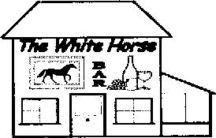
At that time, Mr. Webster was much worried about his bar. One day a friend of his came, looked around and said, "Take down the picture of the white horse and change it for a picture of a black one."
" 77 " Mr. Webster said.
"Yes, but just do it." his friend said and went out of the bar.
Mr. Webster went to an artist and said, " 78
The next day a picture of a black horse appeared on the wall. Soon after the door opened, a man came in and shouted, " 79 The picture on the wall is different from the name." Then he sat down and drank something.
80 and then another and another. A lot of people came in and said, "The picture on your wall is wrong." But they all stopped and drank in Mr. Webster's bar.
From then on, Mr. Webster was happy again.

A．But the name of the bar is The White Horse．
B．Another man came in and said the same，
C．Now everything in the bar goes well，
D．I want a picture of a black horse．
E．There’s a great mistake!

第二卷
(E)
Cellphones help us easily find people anywhere at any time. However, using cellphones too often may cause cancer. It's reported that people who used a cellphone for 10 years or more were more likely to get brain cancer.
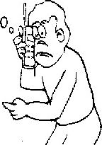
The suggestions below may help you reduce the risk (风险) of cancer:
◆ When using your cellphone, try to keep it away from your body as much as possible. Don't put it under your pillow (枕头) or on a bedside table when you go to sleep.
◆ When you're on the cellphone, use the speaker. In this way, you have just 1/100th of the contact (接触) with radiation you have when you hold it to your ear. An earphone is also a good idea.
◆ Try to keep your conversations short. If you need to talk longer, use an ordinary phone instead.
◆ Change ears when you're using your cellphone. Before putting it to your ear, wait until the person you are calling picks up the phone.
◆ Your phone gives out radiation when you talk or text (发短信), but not when you're listening or getting messages. Listening more and talking less can lower the risk of cancer.
◆ Do not use your cellphone when the signal (信号) is weak or when moving at a high speed, for example in a car or train. At high speeds your phone is trying to pick up signals, and this increases the radiation it gives out.

任务型阅读：根据短文内容，填写下列表格。(10分)
Healthy tips on cellphone use
☆ Try to 8 l your cellphone away from your body, both when using it and sleeping．
☆ Using the speaker or an 82 is a good way to reduce the radiation．
☆ Avoid using a cellphone to make 83 conversations．
☆ Don’t press the cellphone to your ear until the person you are calling 84 the phone．
☆ Listening more and talking 85 can lower the risk of cancer.
☆ Don’t use your cellphone when the signal is 86 or when moving at a high speed．

第四部分 语言知识运用 (25分)
(A) 词汇运用：(10分)
◆选择括号内恰当的单词或词组填入空白处，使句意完整、正确。
87. －Can you speak English?
－Yes, but only ____________ (little / a little).
88. －Let's go to the ____________ (gym / library) together.
－Great. We can do sports there.
89. －This song ____________ (smells / sounds) beautiful, doesn't it?
－Yes. And it also makes us calm.
90. －Why did you move to the countryside?
－Because the heavy traffic in the city is too ____________ (noisy / quiet).
91. －Jane, don't forget to ____________ (take off / turn off) the TV before going out.
－OK, I will.
◆根据中文提示写出单词或词组，使句意完整、正确。
92. －Whose ____________ (蛋糕) are these?
－They're Jim's.
93. －What are you going to do at the party tomorrow?
－I'll ____________ (弹奏) the piano.
94. －What’s your favorite season?
－ l like ____________ (春天) best. It's a good time to fly kites.
95. － Bill fell off the tree and broke his leg.
－____________ (可怜的) child! He has to stay in bed for long.
96. －Look! The bus is coming.
－Be careful! We can't ____________ (上车) the bus until it stops.
(B) 遣词造句：根据提供的图画和提示词，写一个符合图意的完整、正确的句子。(10分)
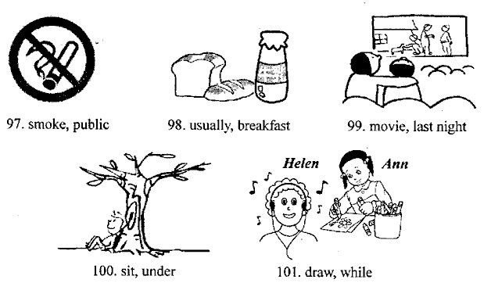
(C) 综合填空：根据短文内容选择方框内的单词，并用其正确的形式填入空白处，使补全后的短文意思通顺，语法正确，结构完整。(5分)

answer travel stand up card politely

As a Chinese teenager, do you often give up your seats to elders? In China, teenagers are encouraged to 102 for those who need help on buses.
However, in London, every teenager from 11 to 15 years old must sign the "courtesy pledge (文明宣言)". It orders teenagers to behave 103 when they travel in the capital. If they don't give up their seats to old, pregnant (怀孕的) or disabled people, or behave impolitely, they will lose their free travel 104
Does that mean they will lose their free cards forever? The 105 is no. If they want to get their cards back, they need to carry out unpaid community work.
"Young people enjoy 106 for free, so they have to take responsibilities (责任). London Mayor (市长) Boris Johnson said.
第五部分 书面表达 (15分)
幸福是什么呢?是下雨时妈妈送来的一把伞．是难过时朋友安慰的几句话，是帮助他人后会心的一笑，还是……？其实幸福很简单，幸福就在你身边。请你以“Happiness”为 题，写一篇英语短文，让我们分享你的感受。词数：80左右。
温馨提示：l、短文中请勿使用真实姓名、地点或所在学校名称。
2、这些词汇也许对你有帮助：
umbrella (n. 雨伞)，treasure(v. 珍惜)，comfort (v．安慰)，share (v．分享)
Happiness
________________________________________________________________________________________________________________________________________________________________________________________________________________________________________________________________________________________________________________________________________________________________________________________________________________________________________________________________________________________________________________________________________________________________________________________________________________________________________________________
附加题：从每小题A、B、C三个选项中，选出能填入空白处的最佳答案。(10分)
1、当你早上遇见同学时，你可以用“__________”表示问候。
A. Good morning! B. Good afternoon! C. Good evening!
2、当妈妈生日时，你可以对她说“__________”。
A. Happy New Year! B. Happy Birthday! C. Happy Teachers' Day!
3、当你与朋友通完电话时，你应该说：“__________”。
A. Bye-bye! B. Hello! C. How do you do?
4、当你不小心踩到别人的脚时，你应说“__________”表示道歉。
A. Thank you. B. How are you? C. I'm sorry.
5、当外籍教师问你在哪个班级时，你可以回答“__________”。
A. I'm 16. B. I'm in Class 2. C. I'm fine.
(注：如果考生全卷得分低于90分，即及格线，则本题的得分将计入全卷总分，但计入后全卷总分最多不超过90分：如果考生全卷得分已经达到或超过90分，则本题的得分不计入全卷总分。)



