岳阳市2012年初中毕业学业考试试卷
英 语


亲爱的同学们，为了让你们更好地发挥出你们的英语水平，
圆满地完成这次考试，作答前，请认真阅读以下事项。
1.本试卷共两卷，满分120分，考试时量120分钟。
2.本试卷分为试题卷和答题卡，所有答案都必须填涂或填写在答题卡
规定的答题区域内。
3.考试结束，考生不得将试题卷、答题卡、草稿纸带出考场。

Good Luck to all of you!

I.听力技能 (共两部分，20小题，每小题1分；共20分)
A) 图片判断 每幅图片你将听到A、B、C三个句子，请根据图片内容，从所听到的句子中选择一个正确答案。听每小题前，你将有时间阅读各个小题，每小题5秒钟；听完后，各小题将给出5秒钟的作答时间。每小题仅读一遍。
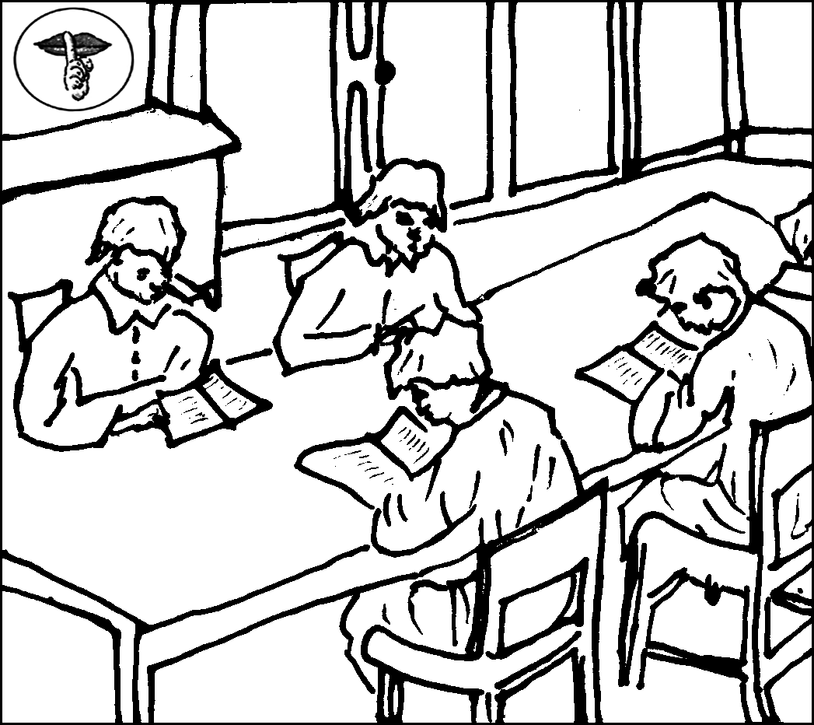
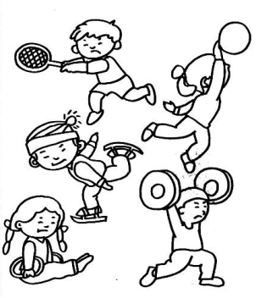
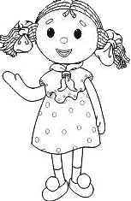

1. A B C 2. A B C 3. A B C
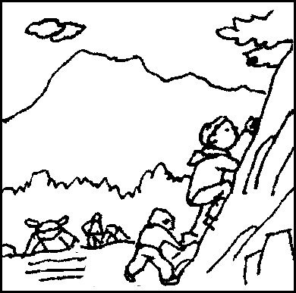
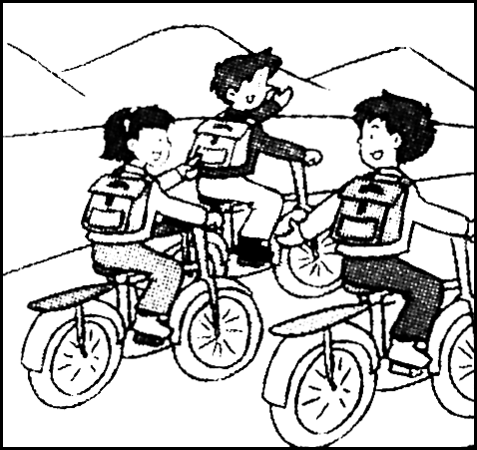

4. A B C 5. A B C

B) 对话理解 你将听到七段对话，根据你所听到的对话内容，从题中所给的A、B、C三个选项中选出最佳答案。听每段对话前，你将有时间阅读各个小题，每小题5秒钟；听完后，各小题将给出5秒钟的作答时间。每段对话读两遍。
听下面一段对话，做第6小题。
（ ）6. What time will they meet ?
A. At 6:30. B. At 6:13. C. At 6:00 .
听下面一段对话，做第7小题。
（ ）7. What’s wrong with the woman ?
A. She wants to buy a car. B. She is going to learn to drive.
C. She wants to see a doctor.
听下面一段对话，做第8小题。
（ ）8. How was Tom’s school trip last Saturday?
A. He didn’t have fun . B. He had great fun. C. The trip was fun.
听下面一段对话，做第9小题。
（ ）9. What color is the man’s ball?
A. Blue. B. Black. C. Black and white.
听下面一段对话，做第10小题。
（ ）10.Where are the man and the woman talking?
A. At a school library. B. In a hospital.
C. In a fast food restaurant.
听下面一段对话，做第11、12小题。
（ ）11. What are they going to do?
A. Go boating. B. Go fishing. C. Go camping.
（ ）12. What’s the weather like?
A. It’s raining. B. It’s sunny. C. It’s snowing.
听下面一段对话，做第13～15小题。
（ ）13.When will the talk be given?
A. Today. B. Next week. C. Next month.
（ ）14. How long has Gina learned computer? She has learned it for more than .
A. one year B. two years C. three years
（ ）15. What does Gina want to be when she grows up?
A. A computer programmer. B. A computer engineer. C. A manager.

C）笔录要点 你将听到一段短文，根据你所听到的短文内容，完成下列表格中16~20小题(每空不超过三个单词)。短文读两遍。

The Voice Of The School(校园之声)
What time | It’s 16 o’clock now. It’s time for you to have a break.
What | Music can help you forget all the 17 .
How | You and your classmates must be 18 to hear your favorite music.
What kind | Western classical(经典的) music makes people feel richer and 19 music makes people do things faster.
Who | Most of 20 like pop music best.

Ⅱ. 知识运用（共两部分，20小题，每小题1分；共20分）
A) 单项填空 从A、B、C三个选项中选择一个最佳答案填空，或回答问题。
( ) 21.Jeremy Lin is the first Chinese-American basketball _____ in the NBA. He is a little different from Yao Ming.
A. dancer B. player C. watcher
( ) 22. A new road was built between our village and the town. _____ road is wide and clean.
A. 不填 B. The C. A
( ) 23. —Do you know the lady ______is talking with Mr. Smith?
—Yes, she’s our new chemistry teacher, Miss Brown.
A. who B. which C. whom
( ) 24. —Who is that?
—It _____ be Shirly. Only she is in red today .
A. could B. may C. must
( ) 25. Wembley Stadium（温布利大球场）is one of the _____ soccer fields in the world.
It will be the place for soccer matches during the Olympics next month.
A. famous B. more famous C. most famous
( ) 26. —What do you think of Zhou Libo?
—I think he does well _____ talk shows. Many people like him.
A. in B. on C. at
( ) 27. —Jimmy isn’t here. Where is he?
—He hurt his arm on the playground just now. He ______ to the school doctor’s.
A. has gone B. has been C. goes
( ) 28 .— How is the movie“Snow White and the Huntsman” ?
— _____wonderful movie it is!
A. How B. How a C. What a
( ) 29. —What else do you need for your trip?
— _____else. I’ve packed everything.
A. Something B. Everything C. Nothing
( ) 30. The car _____ by the policeman because the driver was drunk.
A. stopped B. was stopped C. were stopped
B) 完形填空 通读短文，掌握其大意，然后从各题所给的A、B、C三个选项中选出一个最佳答案。
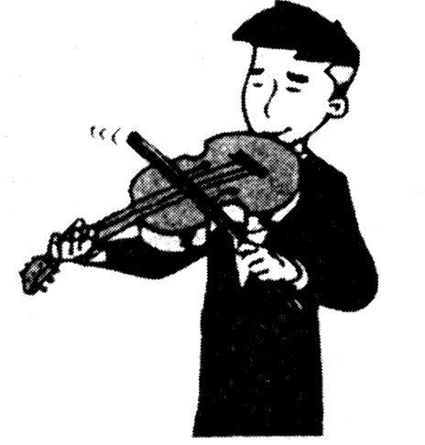
On a Friday night, a young violinist was playing his violin at the entrance (通道口)of the subway station. The music was so wonderful 31 people slowed down to listen and put some money into his hat.
The next day, the violinist came to the entrance again. He 32 his hat as usual. Beside the hat there was a piece of paper. It said,“George Sang has put an important thing 33 my hat by mistake. Welcome to claim(认领) it.” Soon the people went to see the words and they 34 guessed what it could be. After a while, a man came up and said,“I know you would certainly come here.” The violinist asked,“ Did you lose something?”“A lottery ticket(彩票).” The violinist took out a lottery ticket with George’s name on it. George took it and danced 35 .
George was 36 office worker. He bought the lottery and won a prize of $500,000. But when he gave $50 to the violinist for his wonderful music, the lottery ticket was thrown into his hat, too. The 37 was a poor college student. That morning, he was going to fly to Vienna for his education. However, when he 38 the lottery ticket, he didn’t go as he had planned. Instead, he went to the entrance again to wait for the owner of the lottery ticket.
Later someone asked the violinist 39 he didn’t take the lottery ticket to pay for his high education. He said,“Although I don’t have much money, I live happily. If I take the money, I will lose honesty, and I 40 be happy forever.”
( ) 31. A. but B. that C. because
( ) 32. A. put down B. put up C. put on
( ) 33. A. above B. under C. into
( ) 34. A. both B. all C. whole
( ) 35. A. slowly B. happily C. sadly
( ) 36. A. a B. an C. the
( ) 37. A. office worker B. crowd C. violinist
( ) 38. A. looked B. looked for C. found
( ) 39. A. why B. how C. that
( ) 40. A. will B. won’t C. would

Ⅲ. 阅读技能 （共五部分，30小题。41～60小题，每小题2分；61～70小题，每小题1分；共50分）
A)判断正误 阅读下面的材料，判断下列句子是否符合短文内容。符合的写T，不符合的写F。(T = True, F = False)
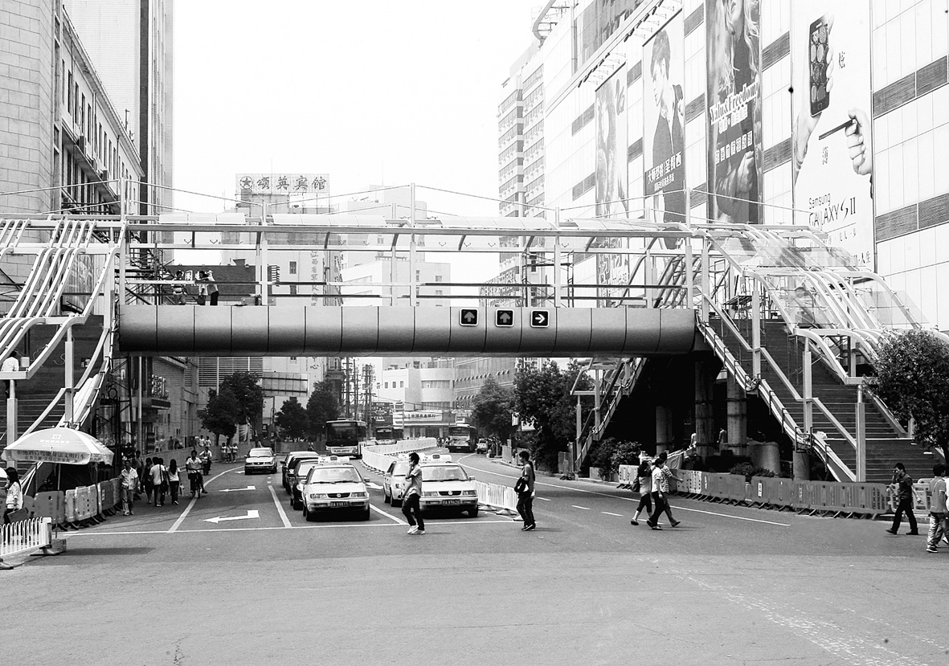
We can see some overhead bridges(天桥) in Yueyang city. There is one near the No.1 People’s Hospital. Another is in front of the Bus Station. As we all know, it is not safe to cross a busy road. These bridges can help people cross the roads safely. Overhead bridges have the same use as street crossings.
Many people think it great trouble to go through overhead bridges. The old and the young think it’s difficult for them to climb up and down the steps of the overhead bridges. But why does the government build so many overhead bridges? That’s because old people and young children walk slowly. And when they cross a busy road using a street crossing, the traffic will be held up or maybe stopped, or even a traffic accident may happen. With the help of the overhead bridges, people and the traffic can move at the same time.
A lot of money has been spent building these overhead bridges. People, old or young should always use them. This can help stop traffic accidents from happening.
( )41. There is only one overhead bridge in Yueyang city.
( )42. It is dangerous for people to cross a busy road.
( )43. All the people like using overhead bridges instead of street crossings.
( )44. Overhead bridges help people and the traffic move at the same time.
( )45. An overhead bridge can help stop a traffic accident from happening.
B)选择答案 阅读下列材料，从A、B、C三个选项中，选出最佳选项回答问题或完成句子。

( )46. What did the German boys
come to Changsha for?
A. To celebrate Children’s Day.
B. To meet pen pals in Changsha.
C. To learn Chinese in Changsha.

( )47. Do you know all of the following phone

For The Police：110
For Information：114
For Fire Engine：119
For Ambulance：120
For Weather：121
For Traffic Aid：122
numbers？Most of them are for emergency
services(应急服务机构). Please choose a
title(标题) for them.
A. Police Phone Numbers
B. Useful Phone Numbers
C. Family Phone Numbers
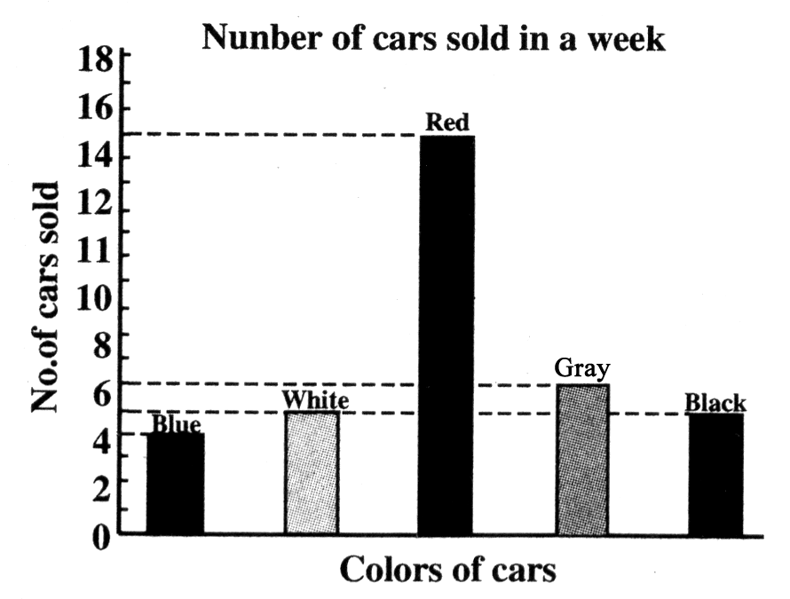
( )48. Now more and more families have
bought cars. From the survey made on
the right, please tell us what color of
cars are the most popular.
A. Gray cars.
B. Blue cars.
C. Red cars.


( )49. If you have one Great
Britain pound, you can
get ______ yuan.
A. 9.5
B. 6.3
C. 8.4

( )50.If you want to get a new pair of
Welcome to HILO’s Store
Bring any of old pair of shoes in and you will pay ten pounds less for any new pair of HILO’s shoes.
Address: No.5 Stone Street
Tel: 245591
shoes for 119 pounds in HILO’s
store with an old pair, how much
will you pay for them?
A. 109 pounds.
B. 119 pounds.
C. 129 pounds.
C)回答问题 阅读短文，然后根据短文内容, 简要回答下列问题。
Li Wei’s College Dream
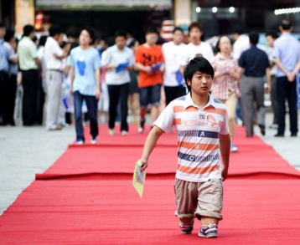
Li Wei, a 22-year-old young man is named “Strong Brother”by netizens (网友). He walked on his knees all the
way to the 2011 national college entrance examination（高考）room. He was born in a poor family in Shanxi province. But unluckily, a traffic accident took away his legs when he was only 3 years old. His life has changed since then. Without feet, he had to spend most of his time practicing walking on his hands and knees. Everybody who sees Li Wei for the first time is surprised to see that he can easily play tennis or climb up stairs without feet. Some people even think he still has feet, but has short legs.
With hard work, Li Wei finished all his school study. In 2011, he became a college student in Chongqing Normal University. Now he has been enjoying his college life. And he received a new pair of artificial legs(假肢) from China Disabled Person’s Federation(残联).
He likes the popular song which says“I know my future is not a dream, I will live happily for every minute of my life. My future is not a dream. My heart moves with the hope…”. Follow your dream, and it will come true one day.
51. What is the name that netizens give to Li Wei?

52. How old was Li Wei when the traffic accident took away his legs?

53. Can he walk or play sports without feet?

54. When did he become a college student in Chongqing Normal University?

55. What do you think of Li Wei from his story?

D)摘录要点 阅读短文，然后在文后表格内完成内容摘要（每空不超过三个单词）。
Here is a page from a magazine called Future. Read the following information about things that may happen in twenty years.
Cars will run on solar power (太阳能) and will be much cleaner and safer. For example, if you are too close to another car or if you are driving dangerously, your car will slow down or stop by itself.
New cities will have to be built in the sea. Some cities on water will have two levels(层). People will live on the upper level, the lower level will be used for traffic, shops and factories.
Biotechnology(生物技术) will make food better and healthier. Plants without insects or illnesses(病虫害) will be developed. The taste of fruit and vegetables will be better and food will be kept longer.
Many new ways to cure(治愈) illnesses will be found. People will use products of genetic engineering(基因产品) to cure more illnesses. However, some new illnesses will appear.
Things | To happen in 56 years.
Cars | To run on solar power; to be much 57 .
New cities | To be 58 in the sea.
Biotechnology | To make food better and healthier, plants will have no insects or illnesses. The 59 of fruit and vegetables will be better and better.
Illnesses | To be cured, some new illnesses will appear, some people have to find new 60 to cure new illnesses.

E)阅读填空 根据下列短文内容，在文中空格处填上一个恰当的词，使短文完整、通顺。
The earth is our homeland. We must look after it. Do you think it’s our duty to 61 the environment? Sure, many famous 62 have started living a green life to set good models(榜样) for us. Some people go to work by bike or 63 foot. Some people often reuse(重复使用) water. For example, 64 they finish washing clothes, they use the water to clean the floor or water flowers. As for students, we can also do things to help. Saving(节约) paper is necessary. Try to make full use of 65 . Don’t throw away the used textbooks but give 66 to your brothers or sisters. And if we don’t want 67 watch TV, turn it
68 in time. On 69 other hand, we 70 plant trees as many as possible.
It’s really important to live a green life, a happier life!

Ⅳ. 写作技能（共三部分，11小题；71～80小题，每小题2分，81小题10分；共30分）
A) 翻译语篇 阅读下面的短文，将文中划线部分译成汉语或英语。
Students learn their lessons in class. Teachers teach them. 71.Students sit in the classroom listening to the teacher. This is the common way of learning. Is this the only way for students to learn? Of course not. 72. 有一些其他的学习方式。Besides listening to teachers, students can learn something by themselves.
As you know, many students in schools have found new ways of learning things by themselves in class. The first thing is to read something they are interested in or they have to read. The second is that before they ask others, they must ask themselves questions that they don’t understand. The third is, 73. to answer the questions themselves by thinking hard, by reading the text or other books. If they still have questions, they may show them to the class. Any student or the teacher who can deal with the questions may answer them in class. 74. 学生们可以互相学习。They are learning by working together. 75.They have found great success in their study. If you keep doing in this way for a long time, you’re sure to succeed in your study, too.
71. __________________________________________________________
72. __________________________________________________________
73. __________________________________________________________
74. __________________________________________________________
75. __________________________________________________________
B) 完成对话 通读下面的对话，然后根据上下文补全对话内容。
Zhang Min—the monitor Lin Feng—a student
Z: Hi, Lin Feng, I want to have a class party before we leave the Junior Middle School.
L: That’s cool.
Z: 76.______________________________?
L: Yes, I will. Linda can also come and help. 77.___________________________?
Z: Hmm…, Let’s have it on June 25. We’ll have a five-day holiday and come back to school on that day for our report cards.
L: 78.______________________________！What can we do at the party?
Z: 79.______________________________.
L: Play party games and have a basketball match? That sounds exciting!
Z: Linda and I can do things for the basketball match. So would you help me with the party games?
L: Sure, 80______________________________. I can’t wait.
C) 作文
81. 今年四月份，岳阳市启动了“文明餐桌行动”，号召全体市民“文明用餐，节俭惜福”。请结合图片，联系实际，适当发挥，以“Save(节约) Food and Eat Healthily”为题，写一篇80-100词的英语短文。文章开头已给出，不计入总词数。
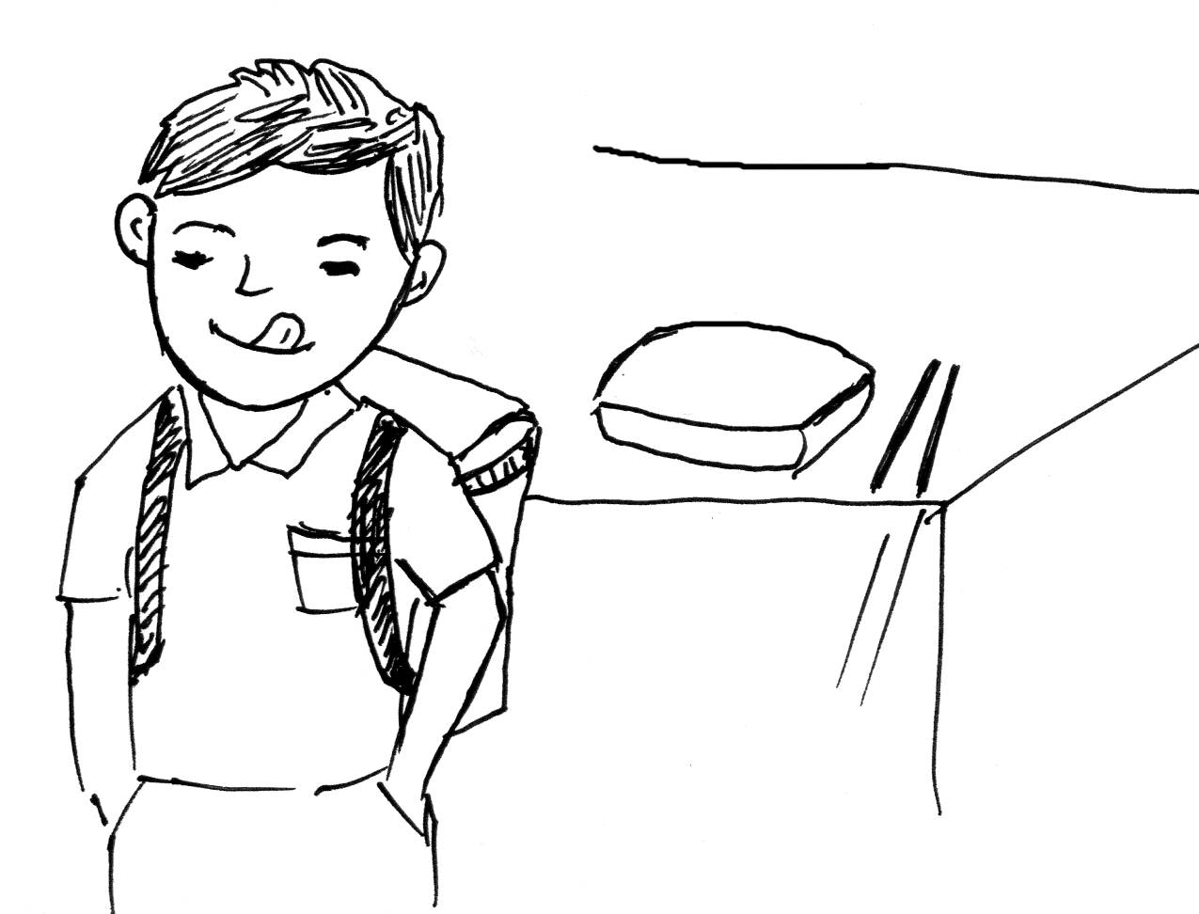
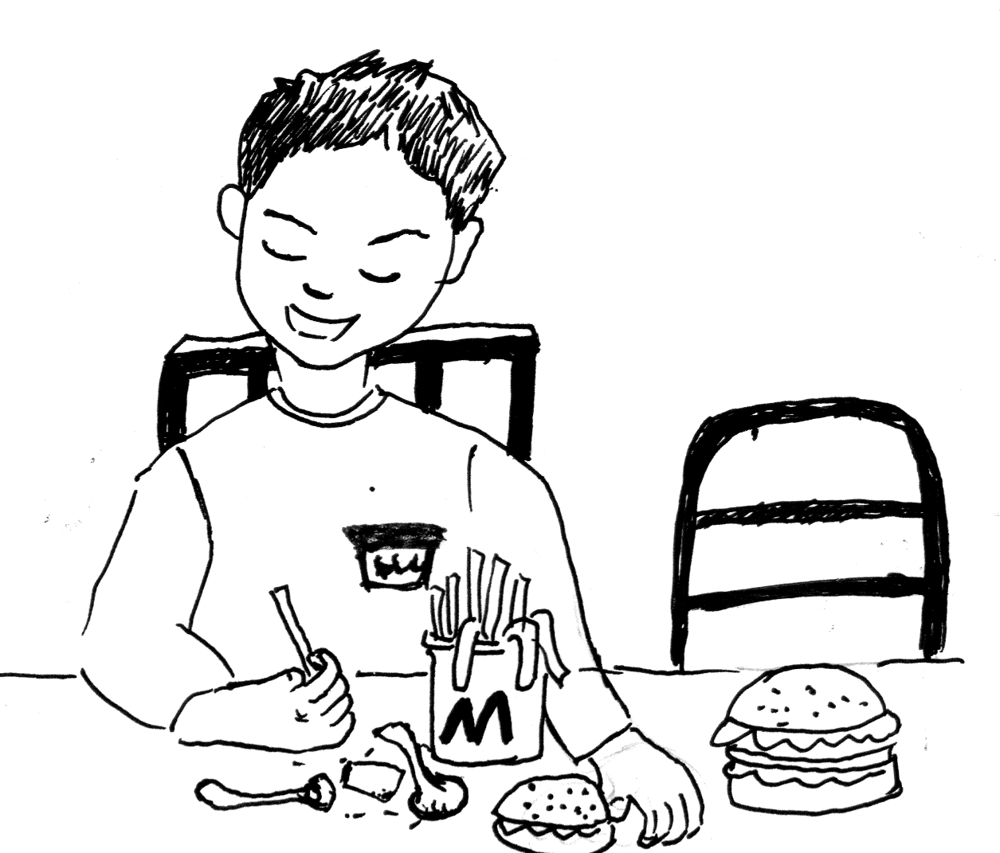
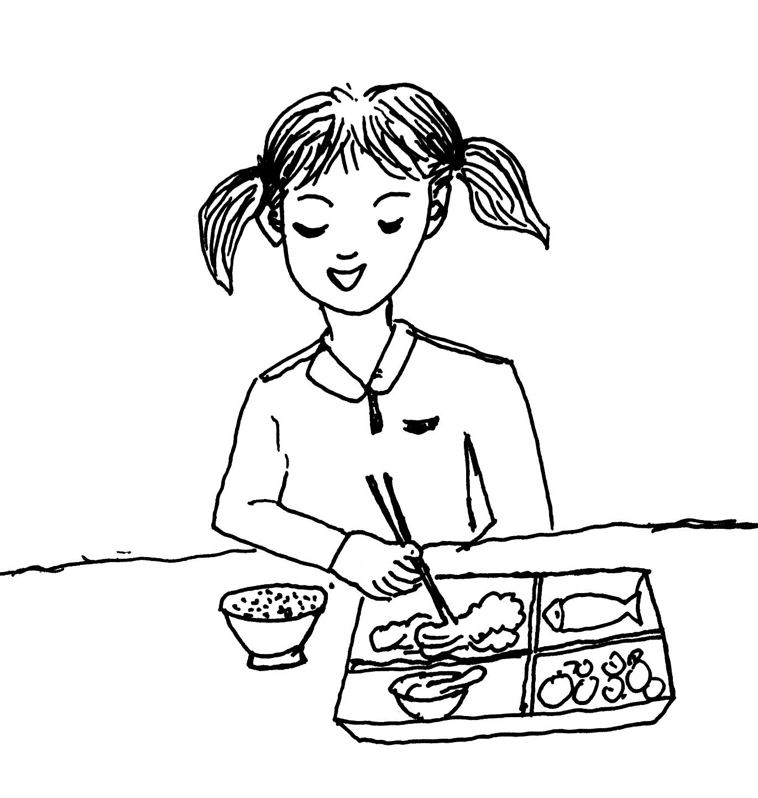
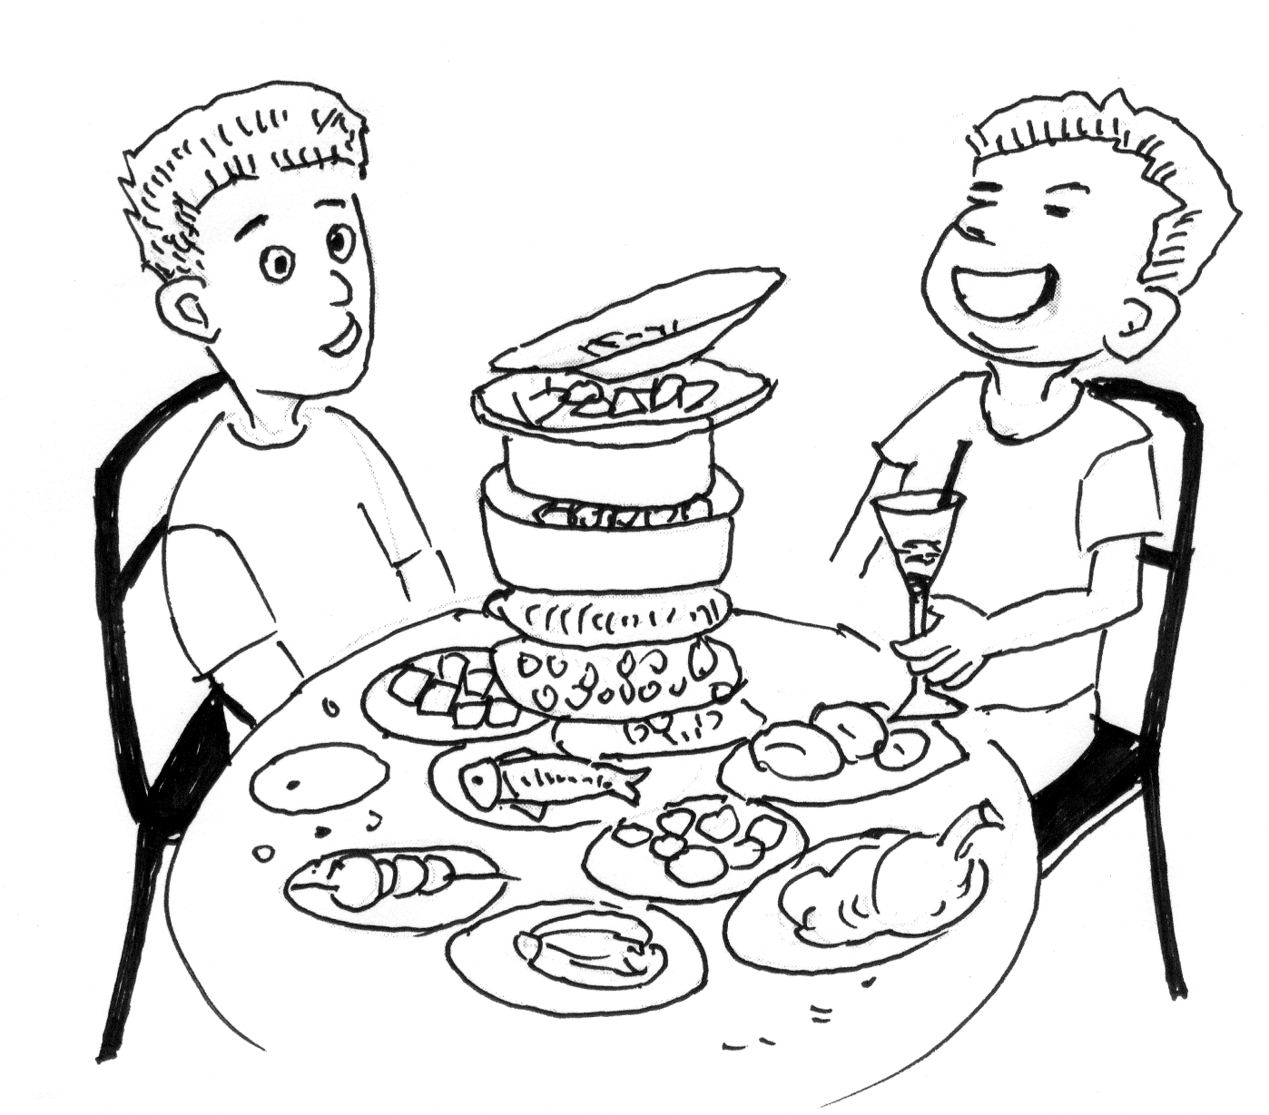

waste too much eat up all the food eat junk food eat a balanced diet

Save Food And Eat Healthily
Yueyang government has called on the citizens to save food and eat healthily so that we can enjoy our happy life. We middle school students should do something for it.
To save food, we



